**HR Analytics Project- Understanding the Attrition in HR**

**Contents**

1. [Problem Definition](https://towardsdatascience.com/building-an-employee-churn-model-in-python-to-develop-a-strategic-retention-plan-57d5bd882c2d#c099)
2. [Data Analysis](https://towardsdatascience.com/building-an-employee-churn-model-in-python-to-develop-a-strategic-retention-plan-57d5bd882c2d#6270)
3. [EDA Concluding Remarks](https://towardsdatascience.com/building-an-employee-churn-model-in-python-to-develop-a-strategic-retention-plan-57d5bd882c2d#030a)
4. [Pre-processing Pipeline](https://towardsdatascience.com/building-an-employee-churn-model-in-python-to-develop-a-strategic-retention-plan-57d5bd882c2d#dd40)
5. [Building Machine Learning Models](https://towardsdatascience.com/building-an-employee-churn-model-in-python-to-develop-a-strategic-retention-plan-57d5bd882c2d#8341)
6. [Concluding Remarks](https://towardsdatascience.com/building-an-employee-churn-model-in-python-to-develop-a-strategic-retention-plan-57d5bd882c2d#13e2)

**ABOUT HR ANALYTICS**

Human resource analytics (HR analytics) is a subset of analytics that involves applying analytic processes to an organization's human resource department in the hopes of maximising employee efficiency and thereby increasing return on investment. HR analytics is more than just collecting data on employee productivity.

Instead, it seeks to also provide insight into each process by collecting data and then analysing it to make informed decisions on how to enhance them.

**Attrition in HR**

Human resource attrition refers to the steady reduction of jobs over time.

In general, a high rate of turnover is a concern for businesses.

HR practitioners also take the lead in developing company incentive plans, work cultures, and motivation strategies that help the company retain top talent.

What is the effect of employee attrition on businesses? How can HR Analytics help with attrition analysis? We'll talk about the first question here, and we'll write the code and try to figure out the method step by step for the second question.

**Attrition affecting Companies**

The financial burden of high employee turnover is a major issue. Job postings, recruiting procedures, documentation, and new hire preparation are all common costs associated with losing and replacing workers. Furthermore, high employee turnover prevents the company from expanding its cumulative expertise and experience over time. This is particularly problematic if the company is customer-facing, as consumers tend to engage with people they know. When you're always hiring new people, you're more likely to make mistakes and have problems.

**Problem Definition**

Employee Attrition (also known as "turnover") is a costly problem for businesses. The true cost of removing an employee can be very high in many cases.

According to a report by the Centre for American Progress, businesses usually pay about one-fifth of an employee's salary to replace them, and the cost will skyrocket if executives or the highest-paid workers are replaced.

In other words, the cost of replacing workers remains high for most businesses. This is due to the time spent interviewing and finding a replacement, as well as sign-on bonuses and the lack of productivity for the first several months as the new employee adjusts to the new job.

Identifying why and when workers are more likely to leave will help you take steps to increase employee engagement and potentially prepare ahead for new hires. I'll take a step-by-step approach with a framework that can be applied to a number of machine learning problems. This project will come under the category of HR Analytics, also known as People Analytics.

*This is a classification problem*

**Data Analysis**

Checking data.

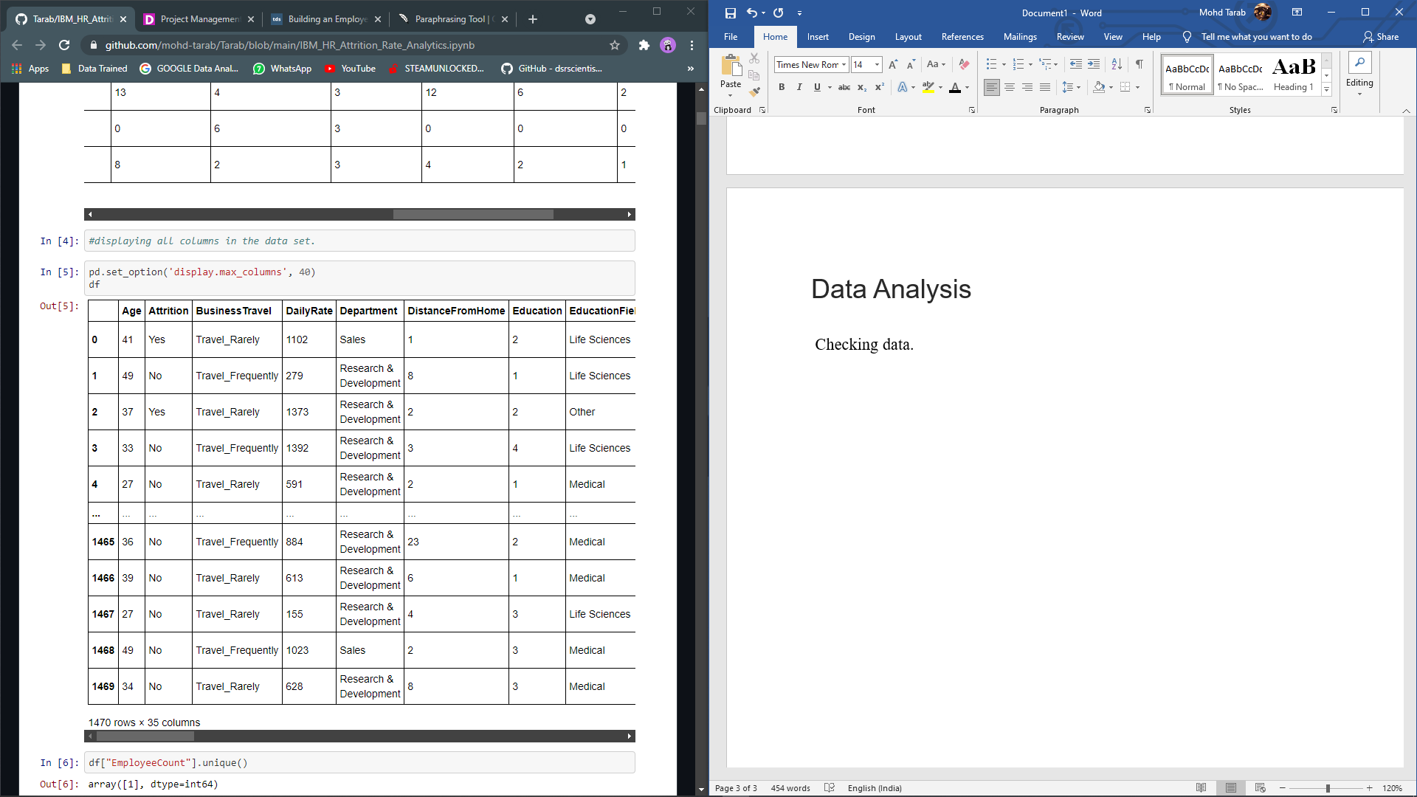

The data has 1470 rows and 35 columns.

Data set description

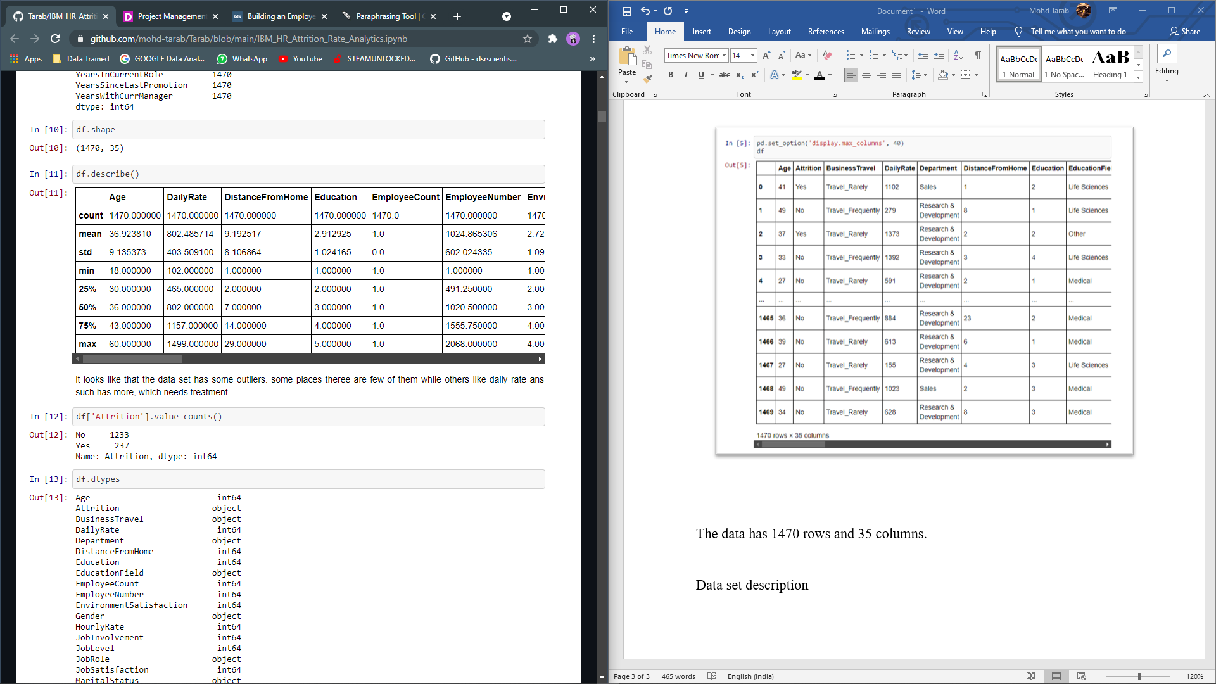

Checking Null values

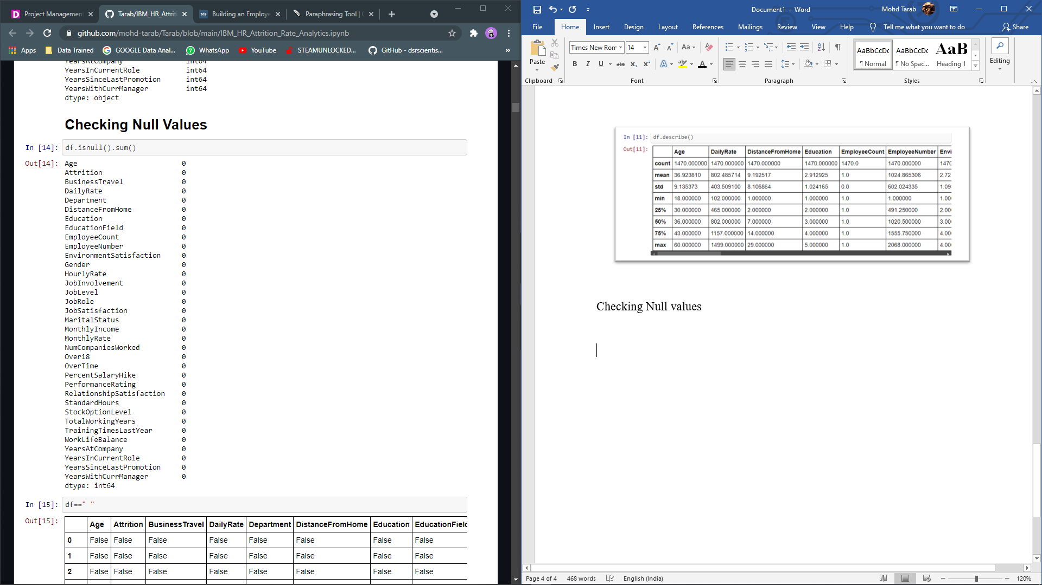

There are no missing values in the information presented. Employee data is unlikely to have a high ratio of missing values in HR Analytics because HR departments usually keep both personal and job data on paper.

**Exploratory data analysis**

Univariate Analysis

Attrition:

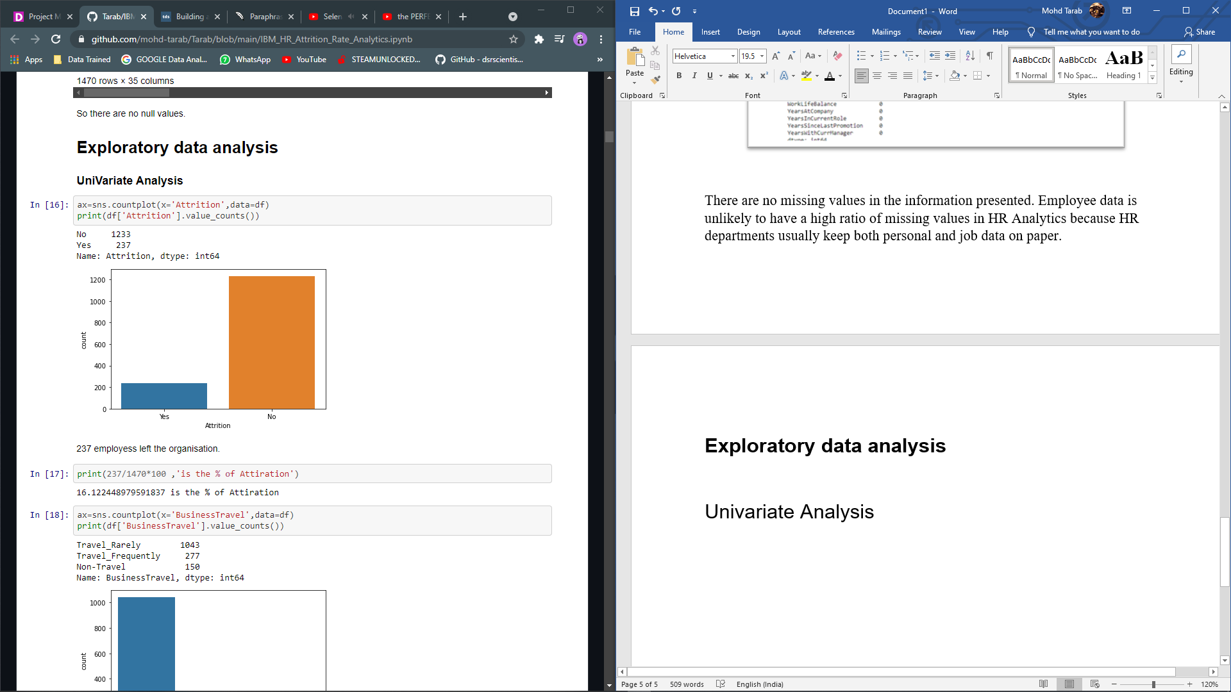

237 employees left the organisation. This shows the attrition rate of employees.

Business Travel:

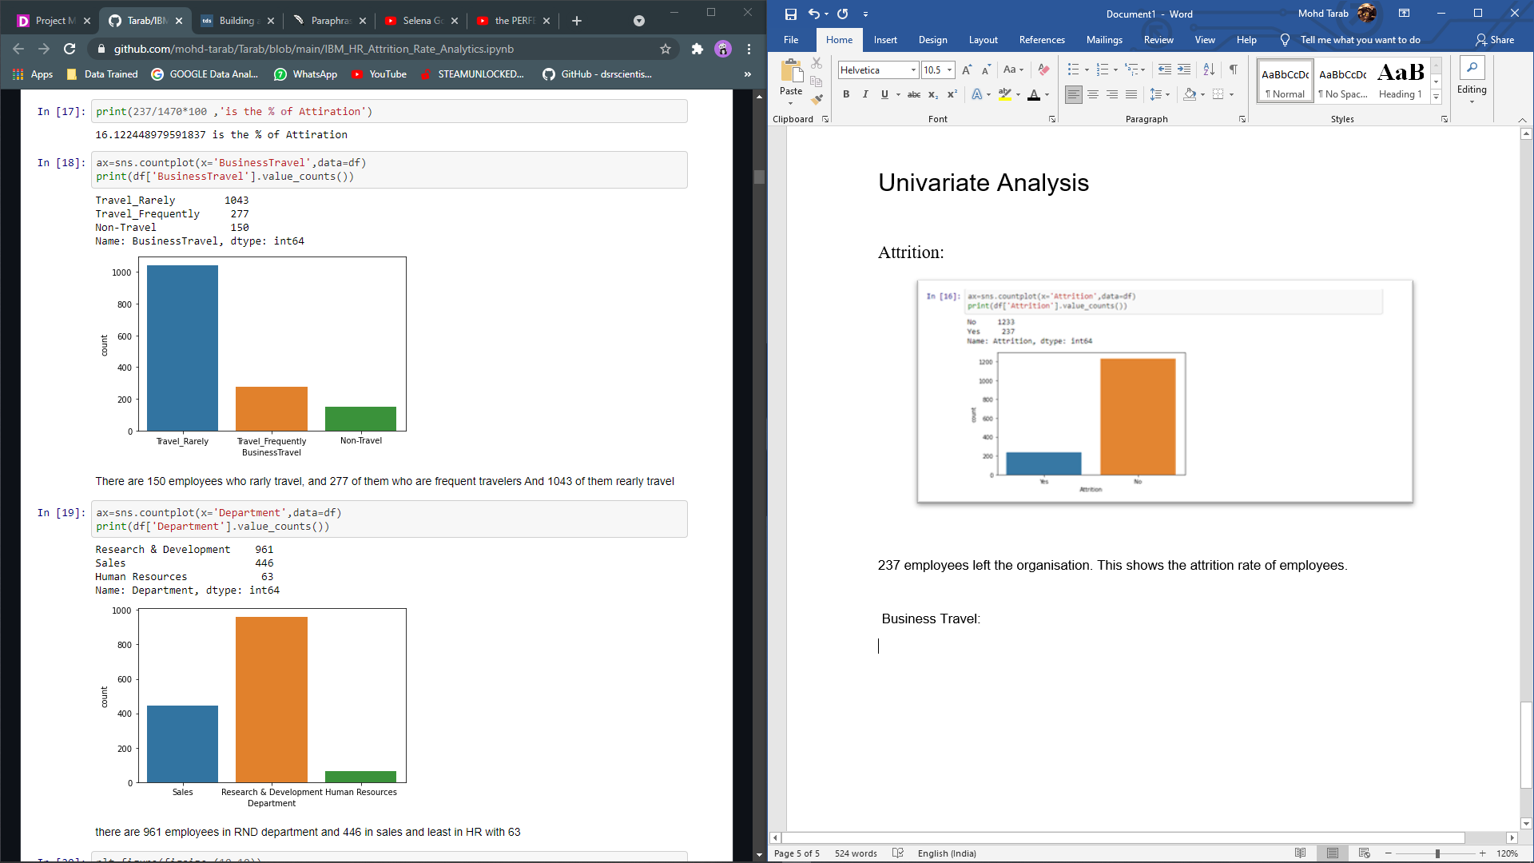

There are 150 employees who non travel, and 277 of them who are frequent travellers And 1043 of them rarely travel.

Department:



This shows from which department an employee belongs that work in IBM.

There are 961 employees in RND department and 446 in sales and least in HR with 63.

Education Field:

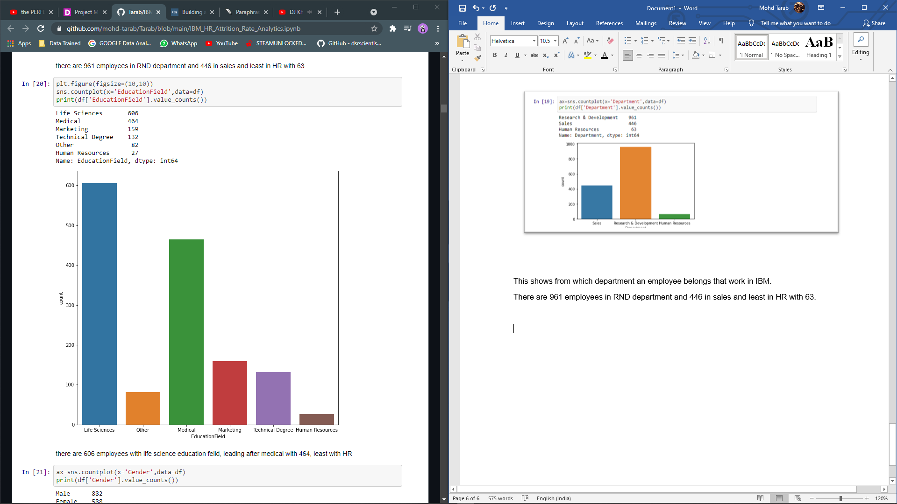

This shows the education background of the employees.

There are 606 employees with life science education field, leading after medical with 464, least with HR.

Gender:

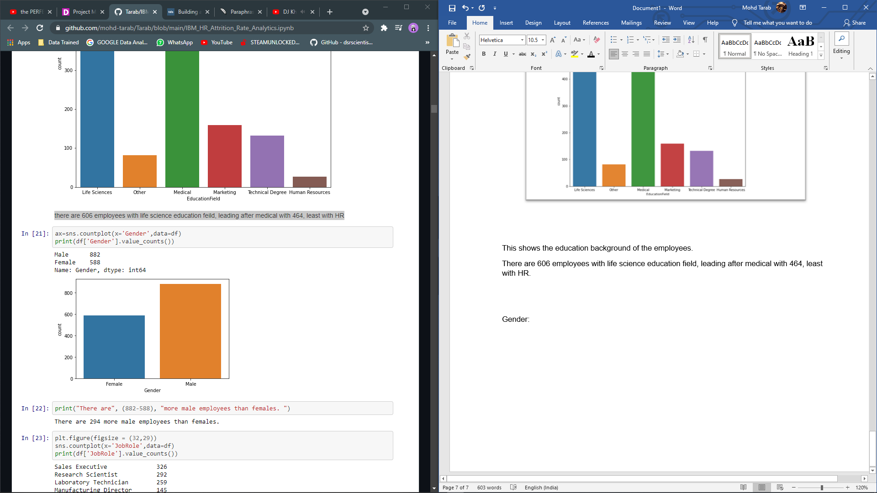

There are 294 more male employees than females.

Job Role:

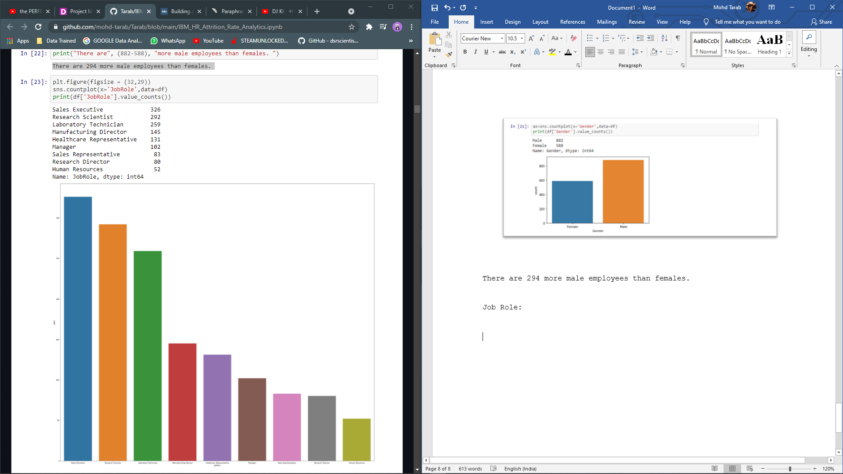

This tells about Roles in the company, there are 326 for Sales Executive job role , and for HR there are 52 being the lowest number of employees in the job role.

Marital Status:

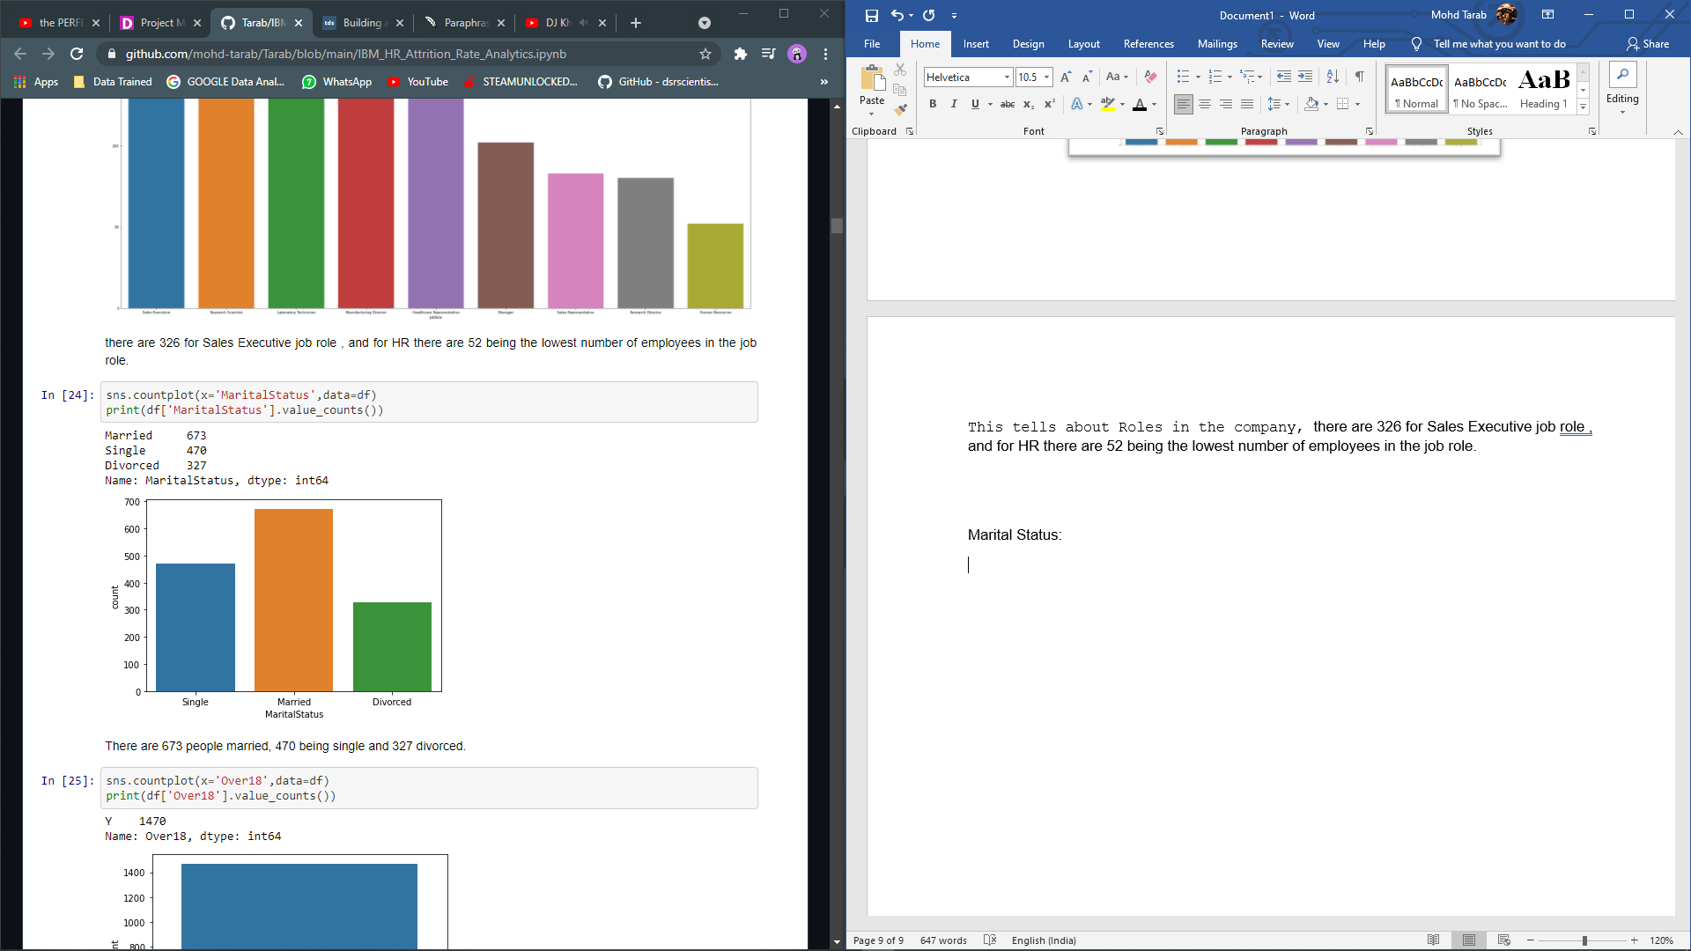

There are 673 people married, 470 being single and 327 divorced.

Over Time:

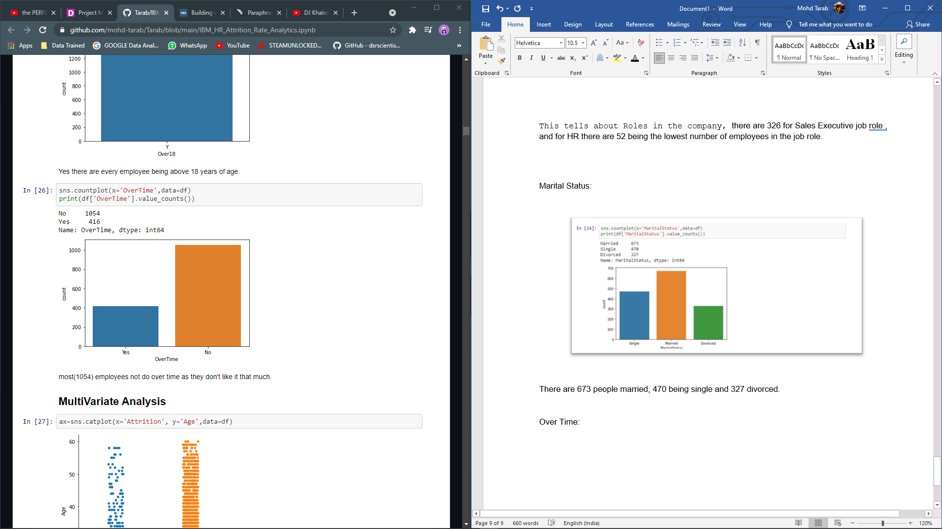

Most (1054) employees not do over time as they don't like it that much.

Bivariate and Multi variate Analysis:

Age and Attrition:

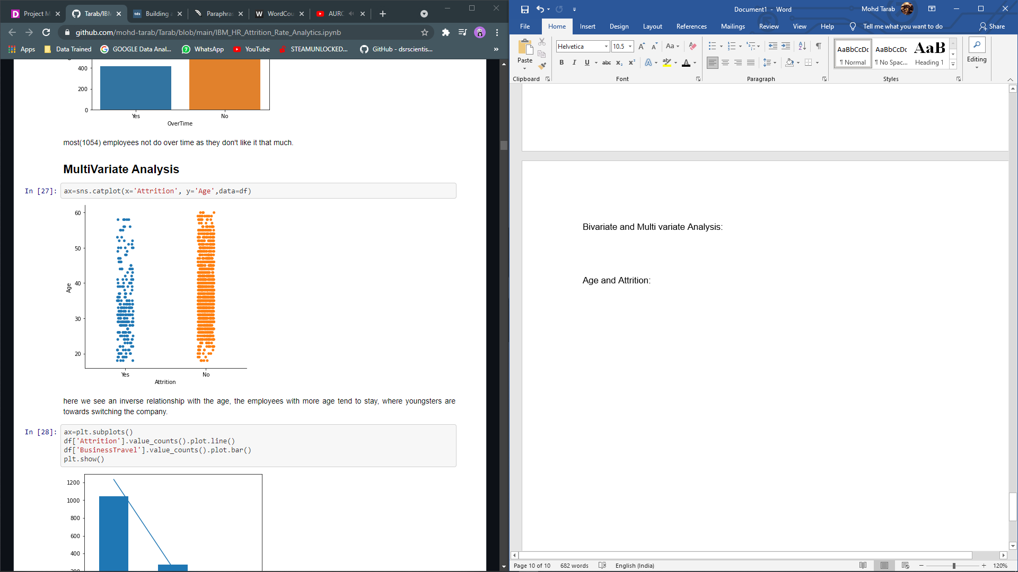

Here we see an inverse relationship with the age, the employees with more age tend to stay, where youngsters are towards switching the company.

Attrition Rate and Business Travel:

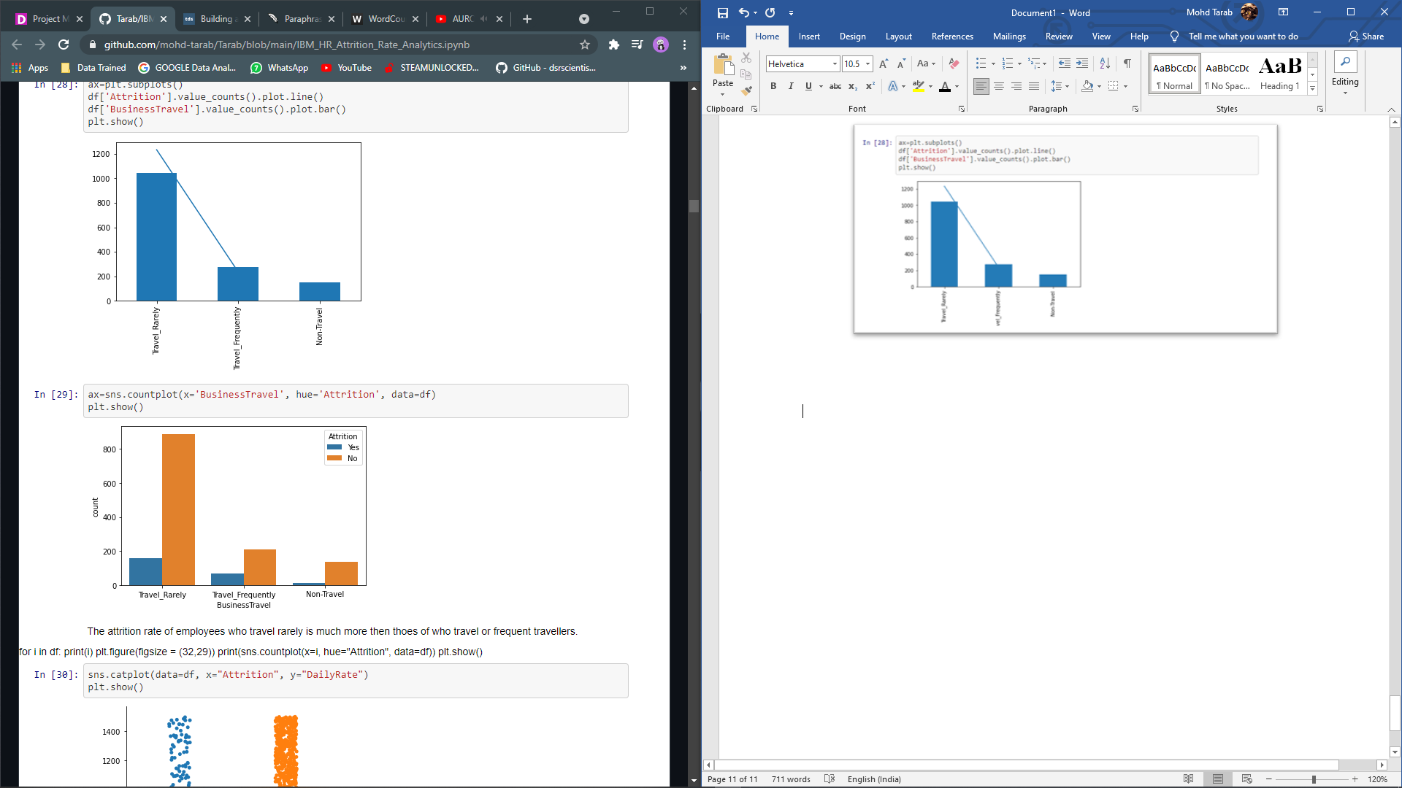

The attrition rate of employees who travel rarely is much more then those of who travel or frequent travellers.

Department and Attrition:

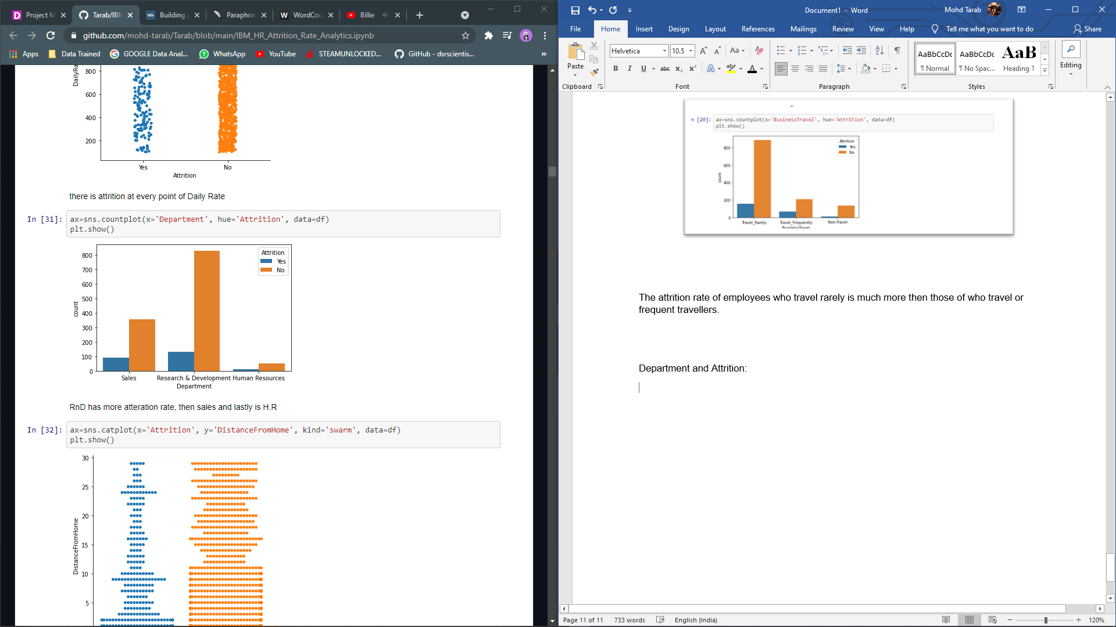

The attrition rate in RND is more than sales and lastly is H.R

Attrition and Distance from home:

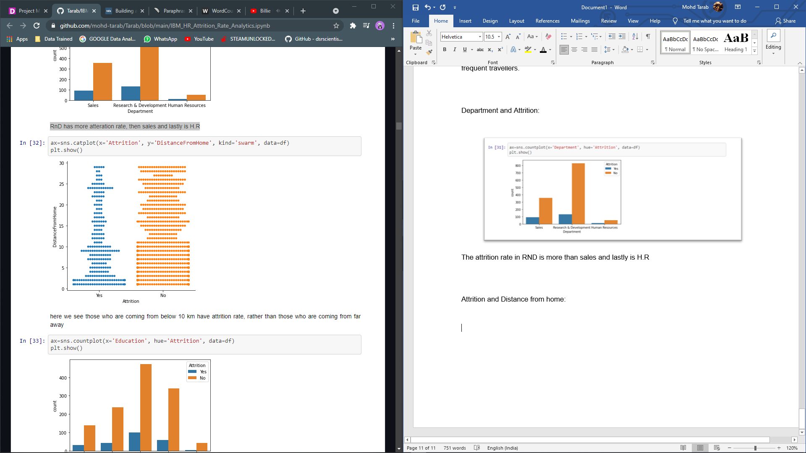

Here we see those who are coming from below 10 km have attrition rate, rather than those who are coming from far away.

Education Field and Attrition

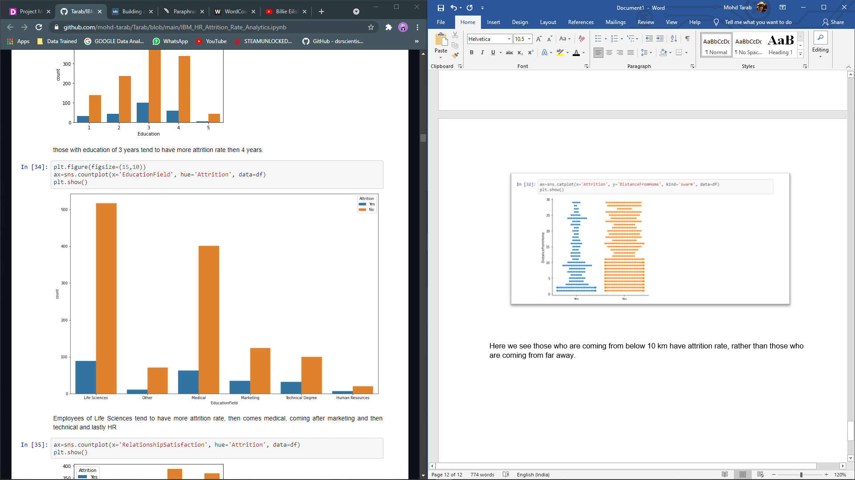

Employees of Life Sciences tend to have more attrition rate, then comes medical, coming after marketing and then technical and lastly HR.

Work Life Balance and Attrition:

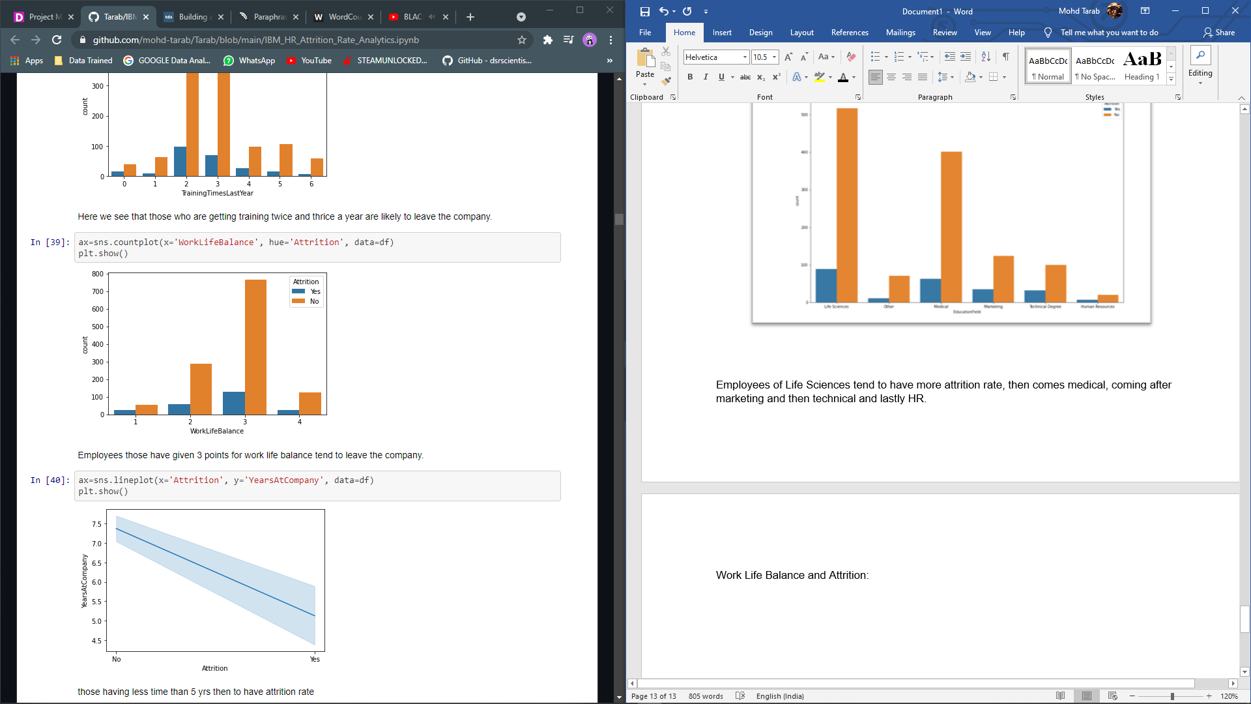

Employees those have given 3 points for work life balance tend to leave the company.

Years at Company and Attrition:

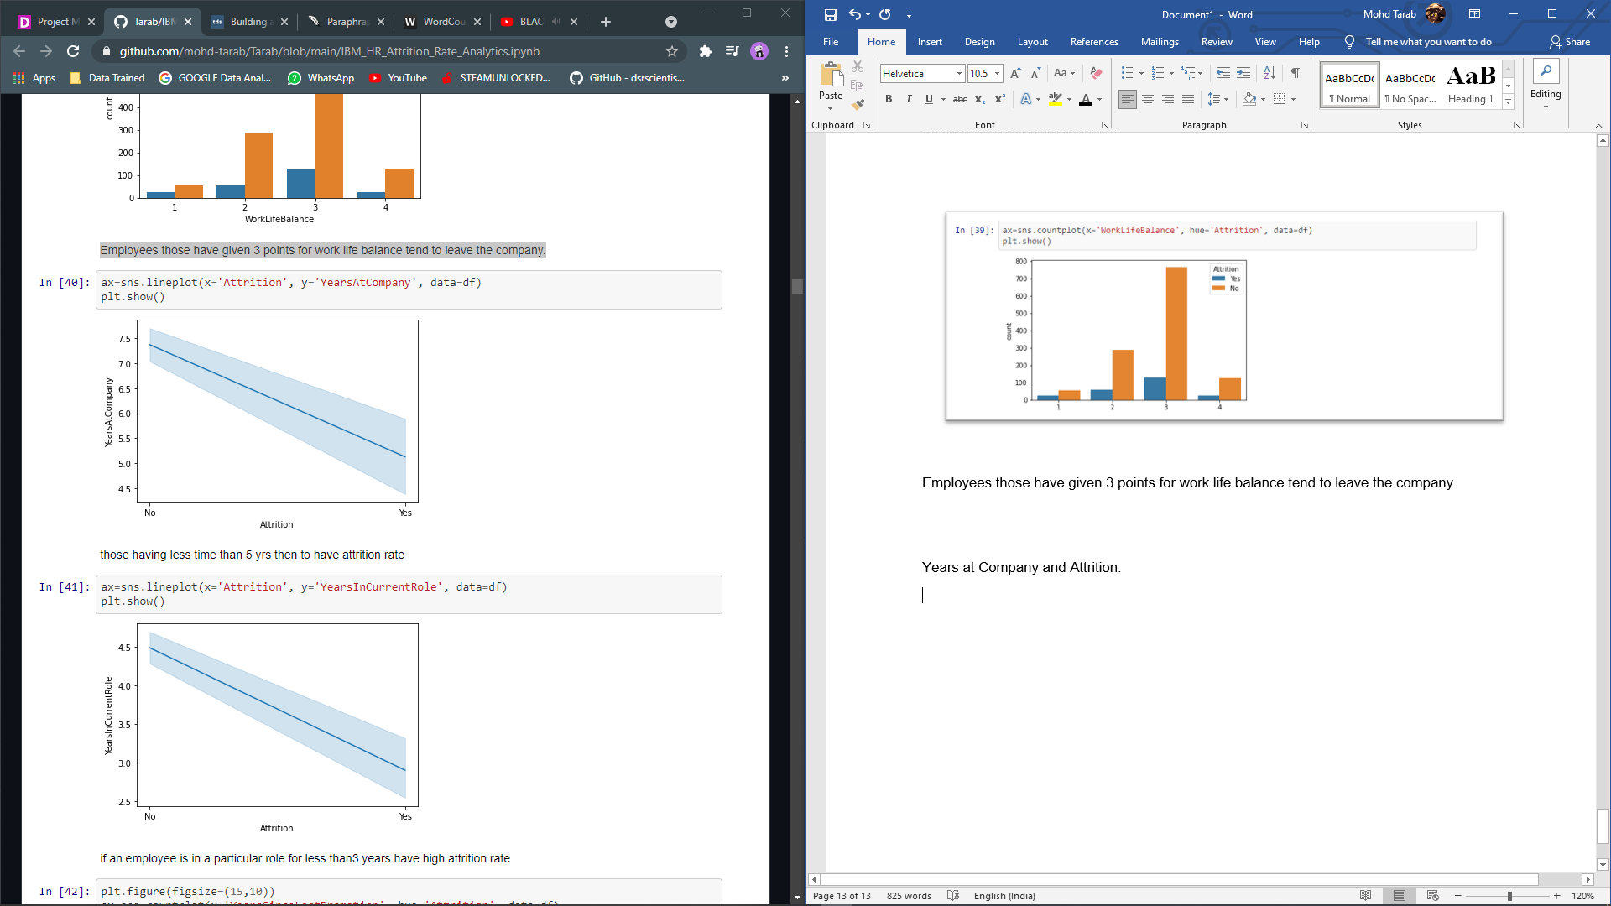

More the number of years at the company tend to have less attrition rate than those who are new to the company.

Gender and Attrition:

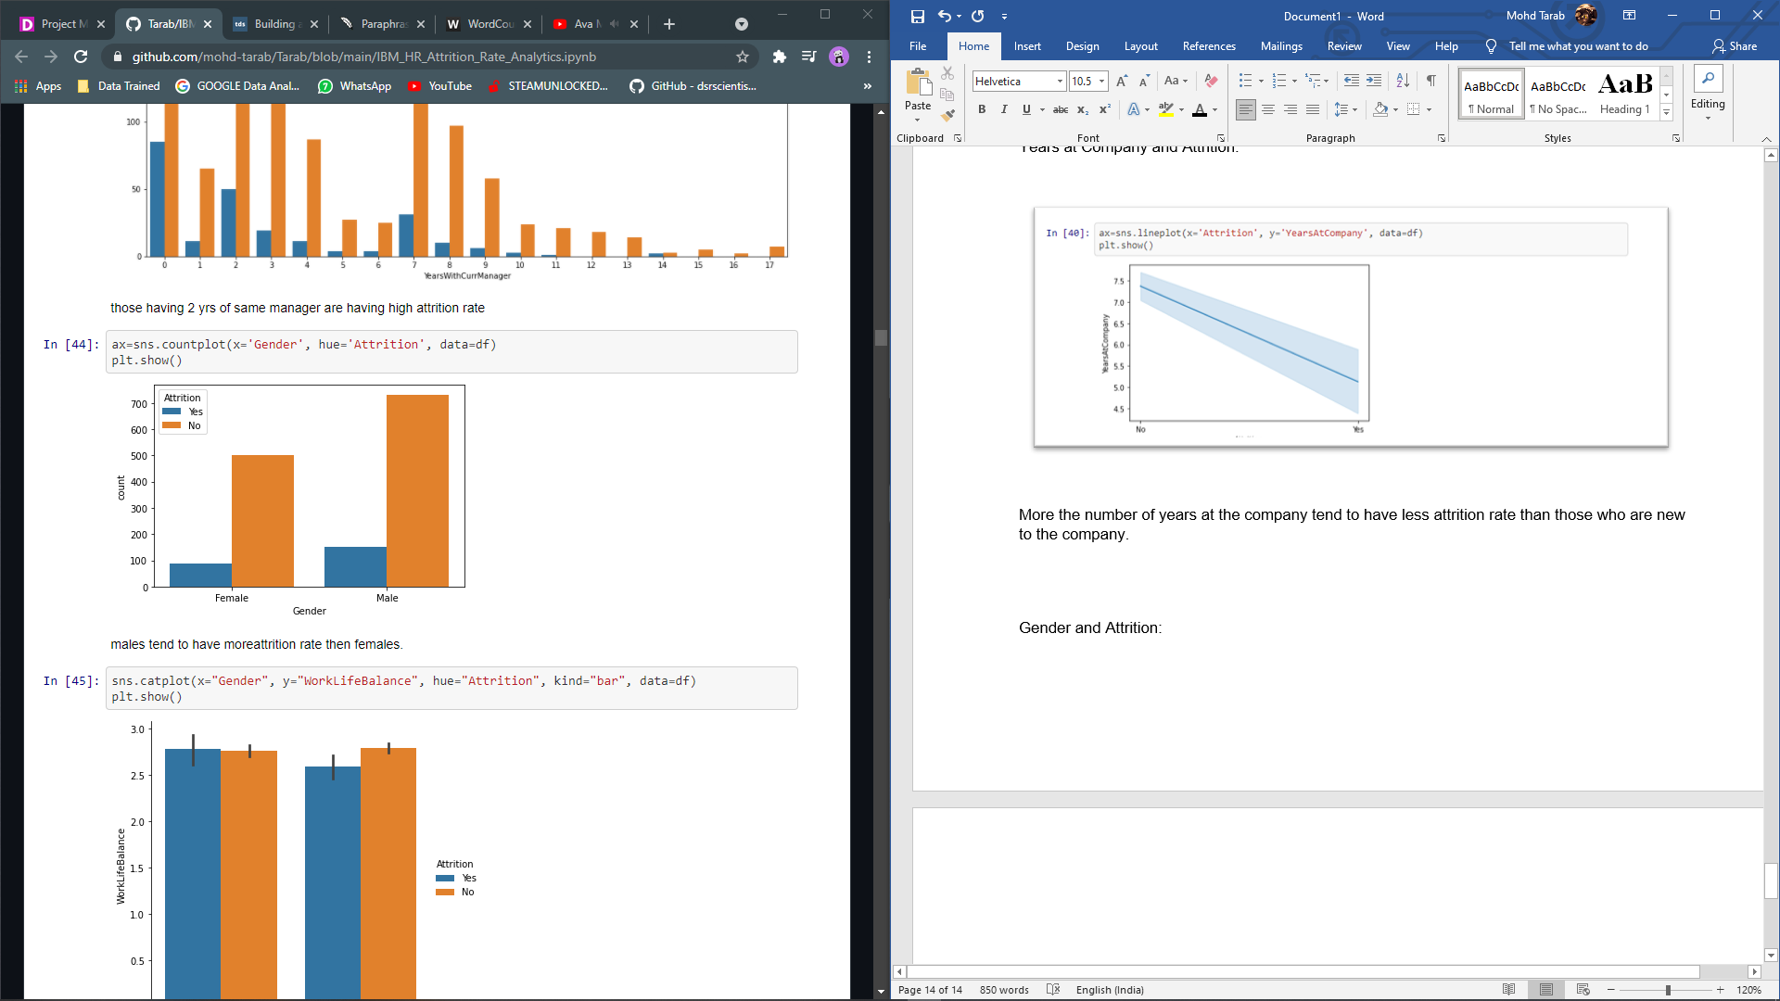

Males’ employees tend to have more attrition rate than females.

Department, Total Working Years and Attrition:

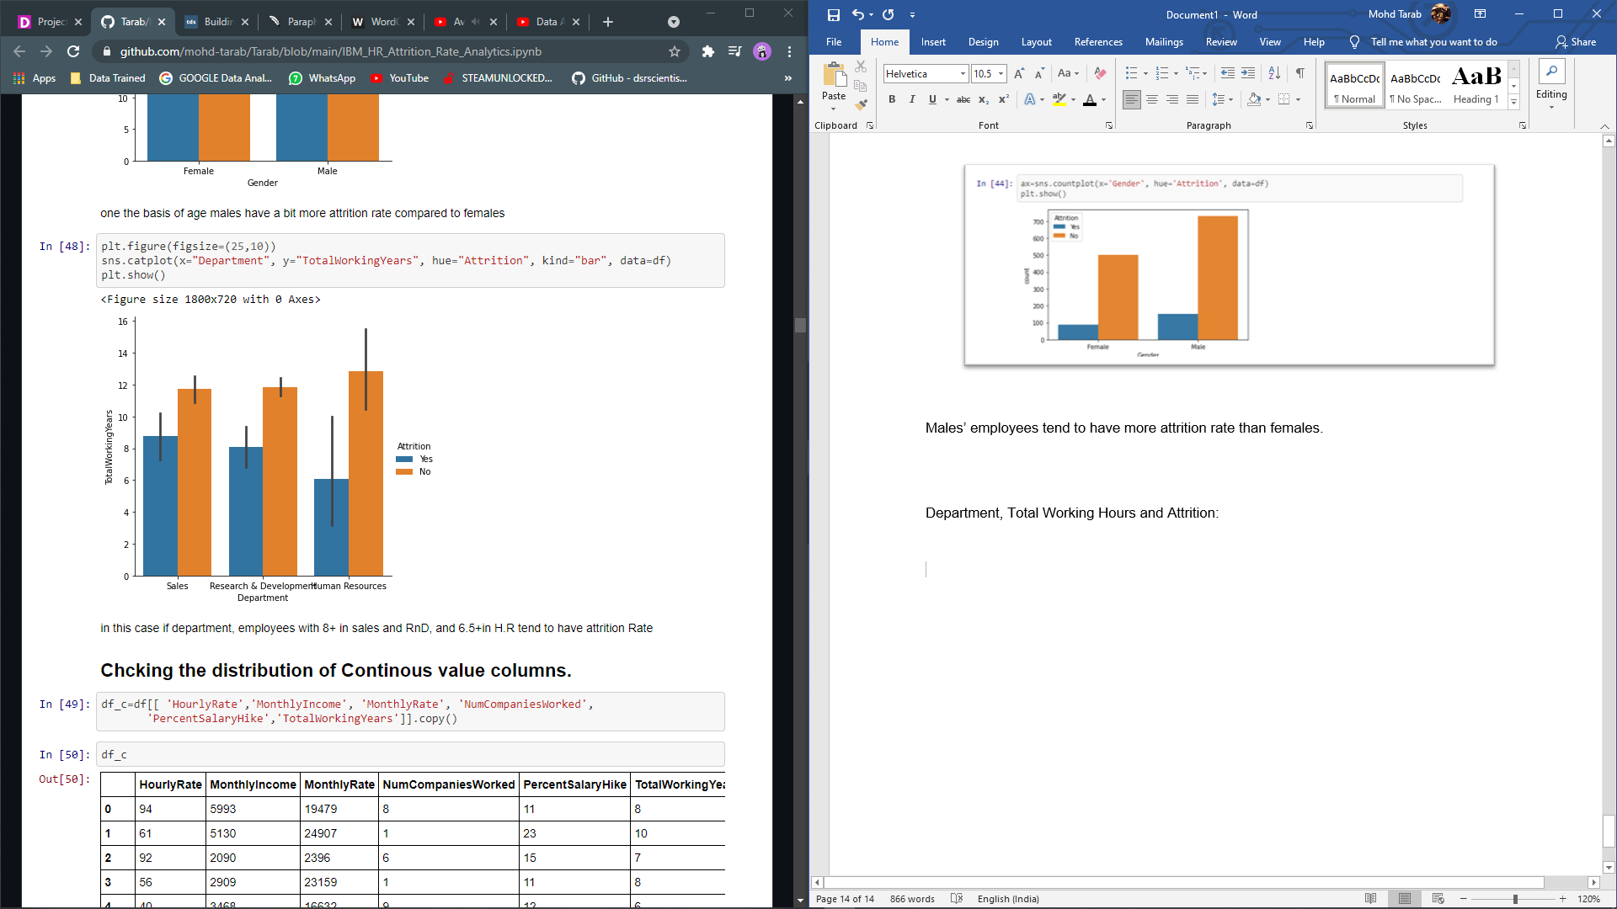

Here we can clearly see that, sale employees with 8+ years have high attrition rate as compared with other departments. The least attrition rate is if HR.

Encoding

In most cases, machine learning algorithms can only use numerical values as predictor variables. As a result, Encoding is needed to encode categorical labels with numerical values. We'll use Ordinal Encoding to avoid adding feature priority for categorical features with a large number of unique values.

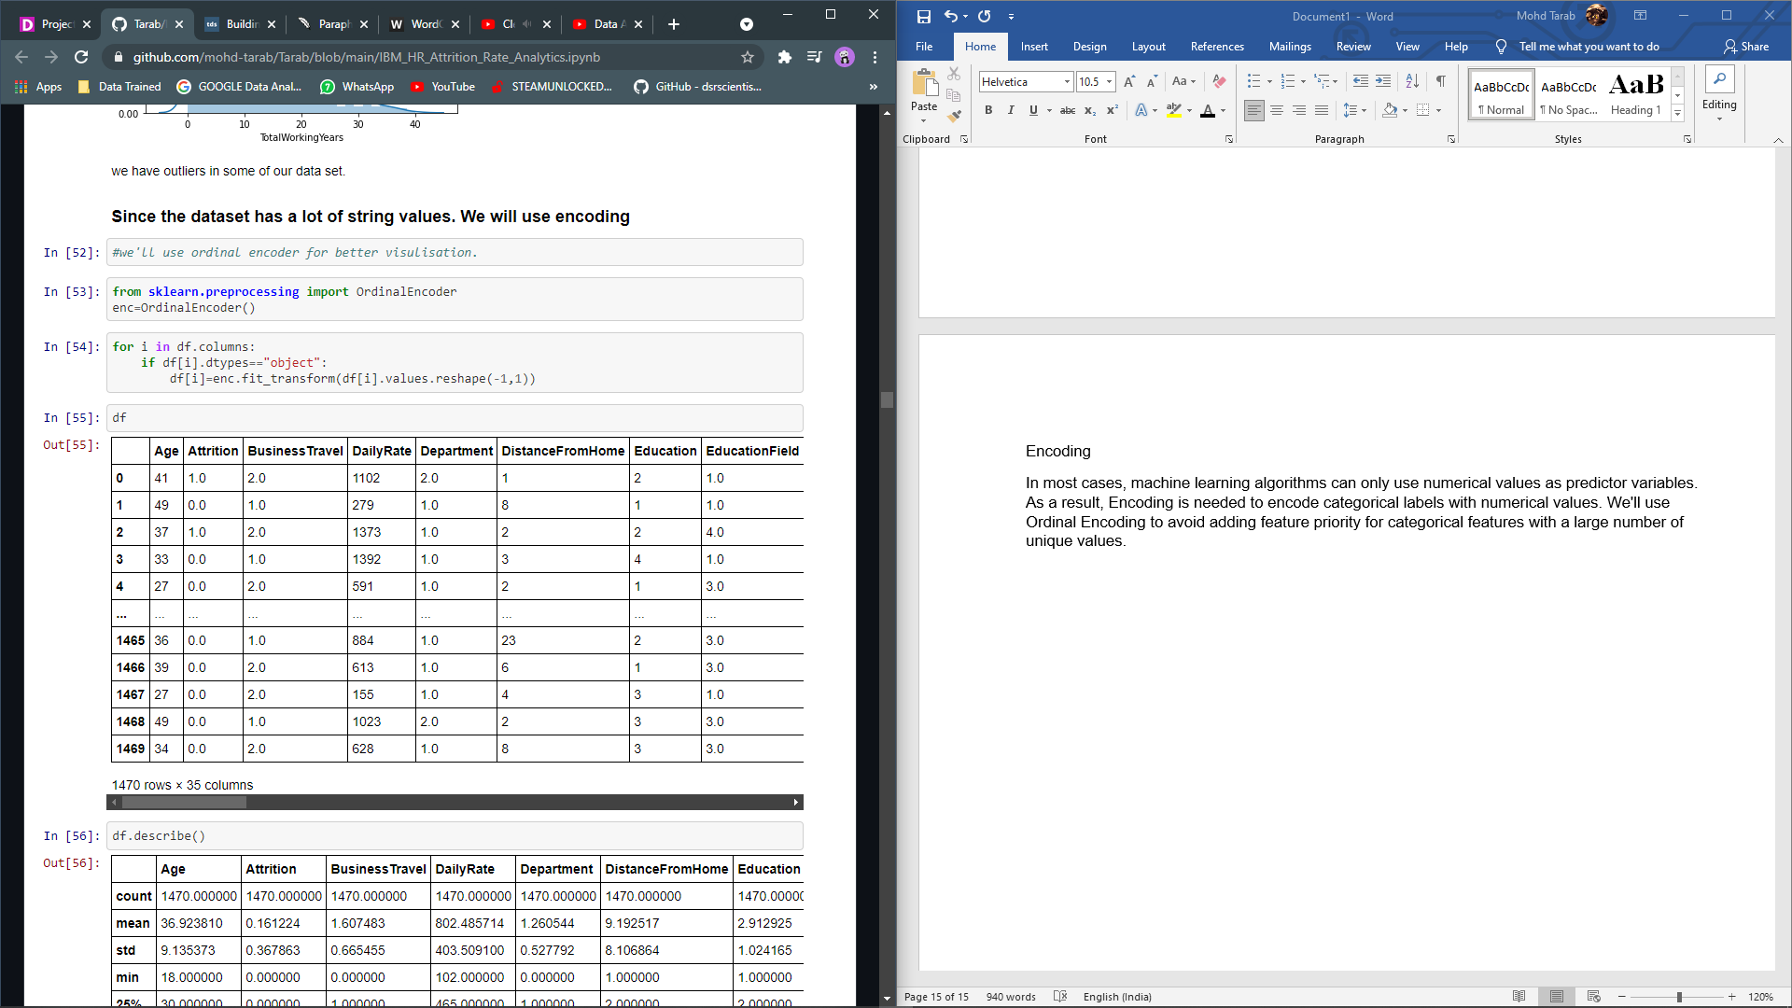

Correlation:

Let's look at some of the most significant correlations. It's important to keep in mind that correlation coefficients are only used to calculate linear correlations.

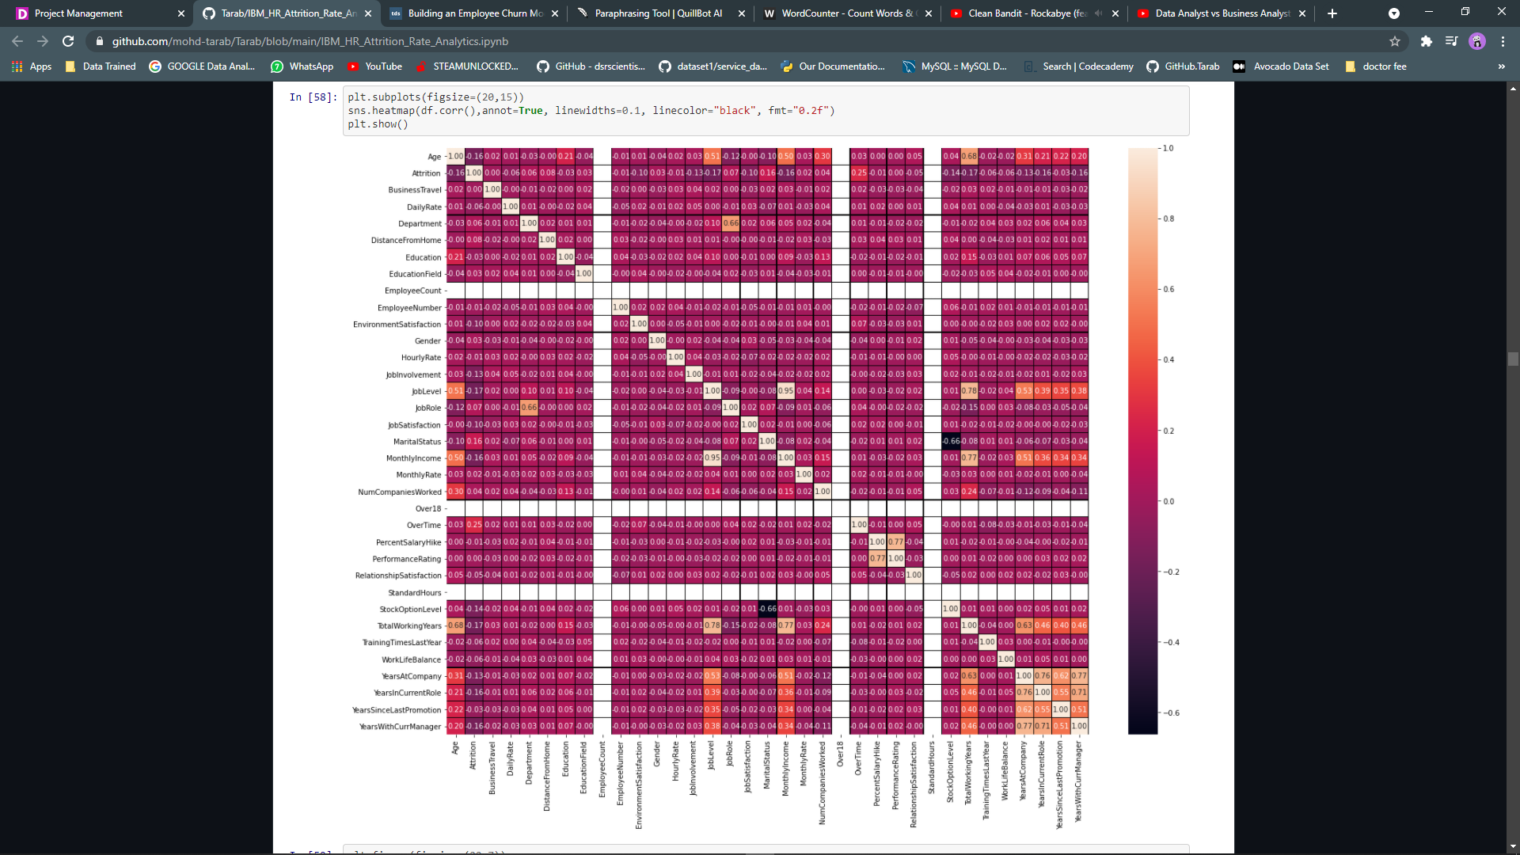

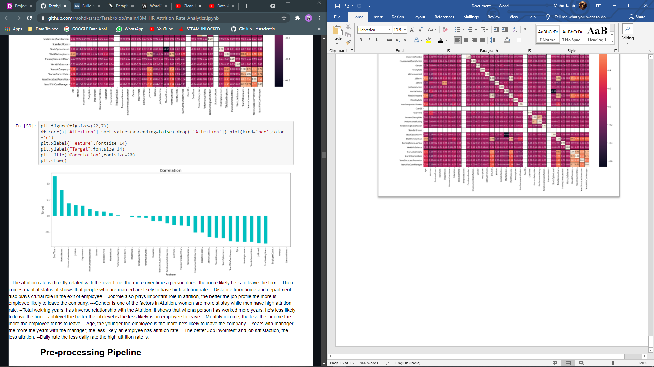

* The attrition rate is directly related with the over time, the more over time a person does, the more likely he is to leave the firm.
* Then comes marital status, it shows that people who are married are likely to have high attrition rate.
* Distance from home and department also plays crucial role in the exit of employee.
* Job role also plays important role in attrition, the better the job profile the more is employee likely to leave the company.
* Gender is one of the factors in Attrition, women are more likely to stay, while men have high attrition rate.
* Total working years, has inverse relationship with the Attrition, it shows that when person has worked more years, he's less likely to leave the firm.
* Job level the better the job level is the less likely is an employee to leave.
* Monthly income, the less the income the more the employee tends to leave.
* Age, the younger the employee is the more he's likely to leave the company.
* Years with manager, the more the years with the manager, the less likely an employee has attrition rate.
* The better Job involvement and job satisfaction, the less attrition.
* Daily rate the less daily rate the high attrition rate is.
* Over time and marital status is highly correlated with the Attrition rate while Total working years Job Level Years in current role are highly negative correlated with the attrition.

**EDA Concluding Remarks**

* There are no missing or incorrect data values in the dataset, and all features are of the right data form.
* Over time and marital status Monthly Rate, Number of Companies Worked, and Distance from Home have the strongest positive associations with the target features.
* Total working years, job level, years in current role, and monthly income have the strongest negative associations with the target features.
* With the majority of findings representing Currently Active Employees, the dataset is unbalanced.
* When compared to their married and divorced counterparts, single workers have the highest percentage of leavers.
* When compared to their peers, people who live farther away from their workplace have a higher proportion of leavers.
* When compared to their peers, people who travel often have a higher proportion of leavers.
* People who are required to work overtime have a higher percentage of leavers than their colleagues.

**Pre-processing Pipeline**

Checking Skewness:

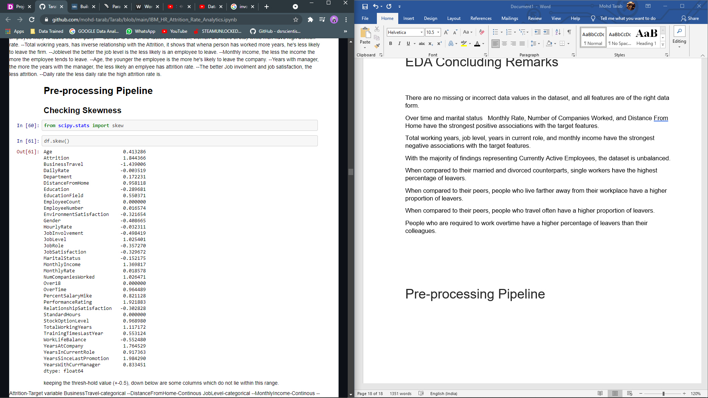

keeping the thresh-hold value (+-0.5), down below are some columns which do not lie within this range.

Attrition-Target variable

Business Travel-categorical

Distance from Home- Continuous

Job Level-categorical

Monthly Income -Continuous

Numb Companies Worked- Continuous

Performance Rating- categorical

Stock Option Level-categorical

Total Working Years- Continuous

Years at Company- Continuous

Years in Current Role- Continuous

Years Since Last Promotion- Continuous

Years with Current Manager- Continuous

we will not treat skewness from categorical data, we will only treat skewness from only continuous data.

To treat skewness, we will be using log transformation and yeo-Johnson

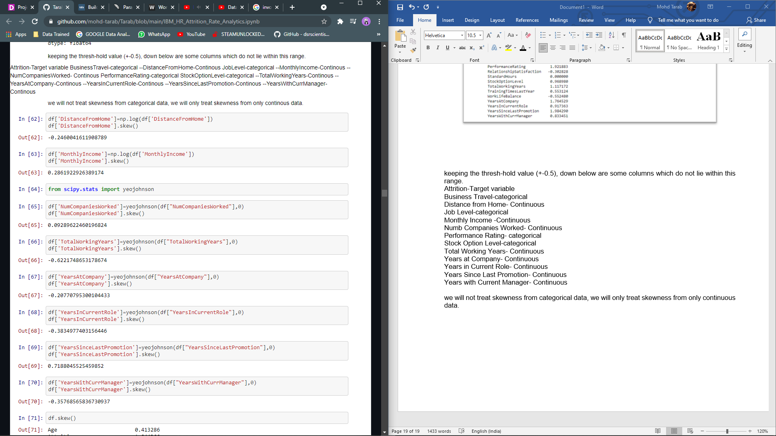

Now the data has been skewed, we'll move forward towards outliers

Checking Outliers

To check outliers, we can use boxplot.

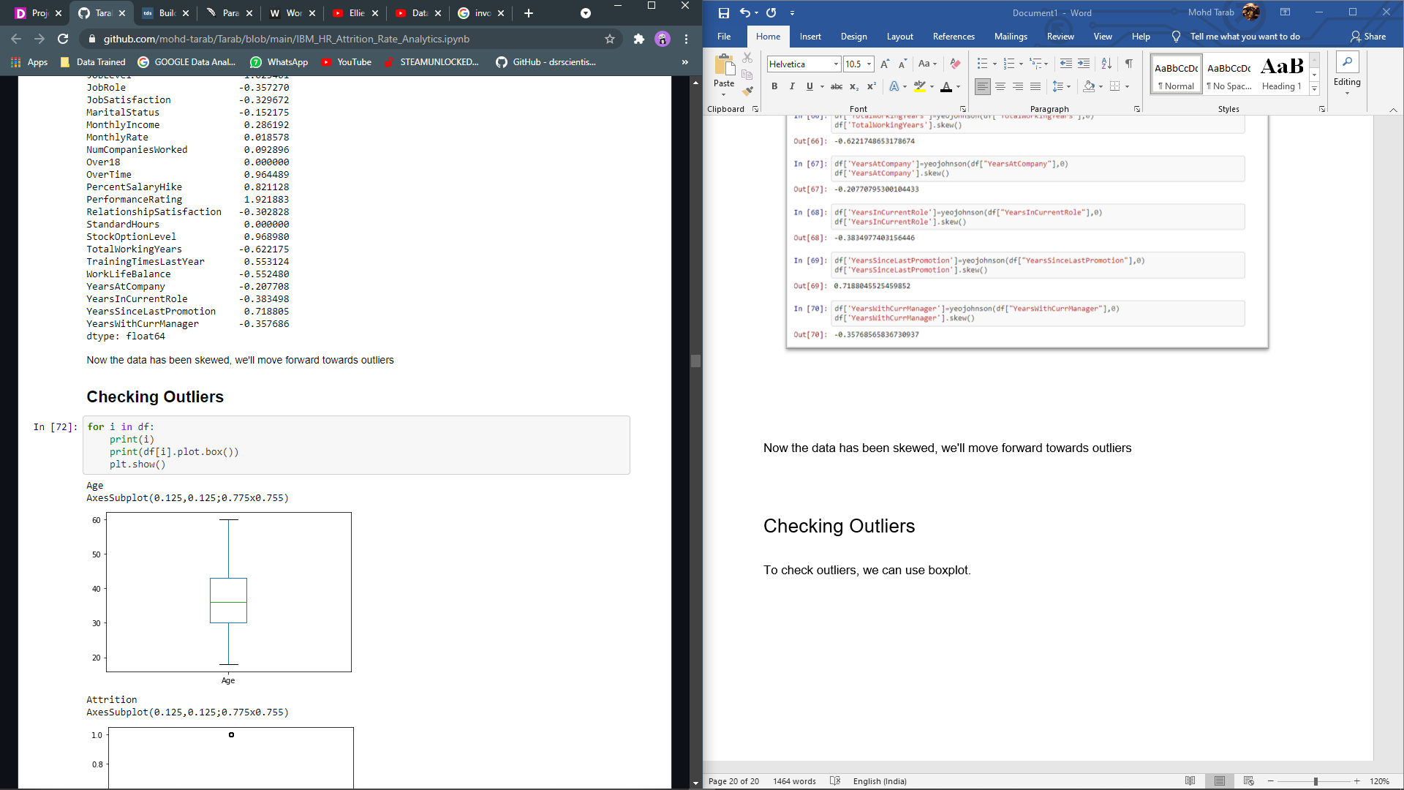

There are very few outliers in Total Working Years, Training Times Last Year and Years At Company.

The best practice is to check which all data is making as outliers for that we will be using .unique() method.

After using .unique() method, we came to a conclusion that outliers should not be removed in any of the columns, Total Working Years, Training Times Last Year, Years at Company, as there might be employees with an experience and those who have attended the Training and Those who are in company since a long time.

Removing these outliers our model will be biased and won’t perform well enough in real-life scenario.

**Making Data Set Ready for Machine Learning Models**

Separating the columns into features and target:

We must decouple the training and testing data frames from our master dataset before implementing or applying any Machine Learning algorithms.

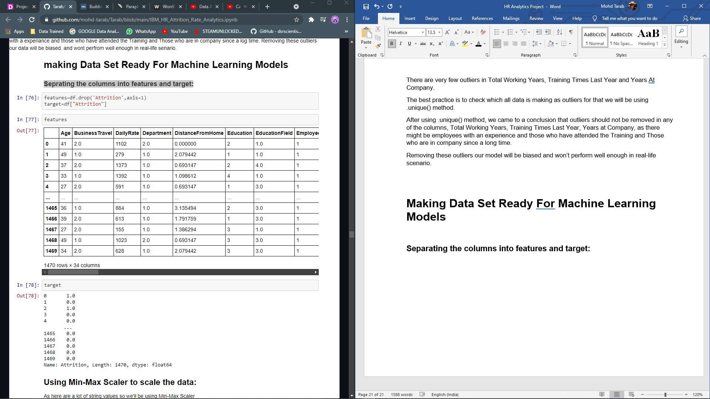

**Scaling features:**

Using MinMaxScaler to shrink the range, the range now falls between 0 and n. When numerical input variables are on a similar scale, Machine Learning algorithms perform better. We're scaling between 0 and 5 in this case.

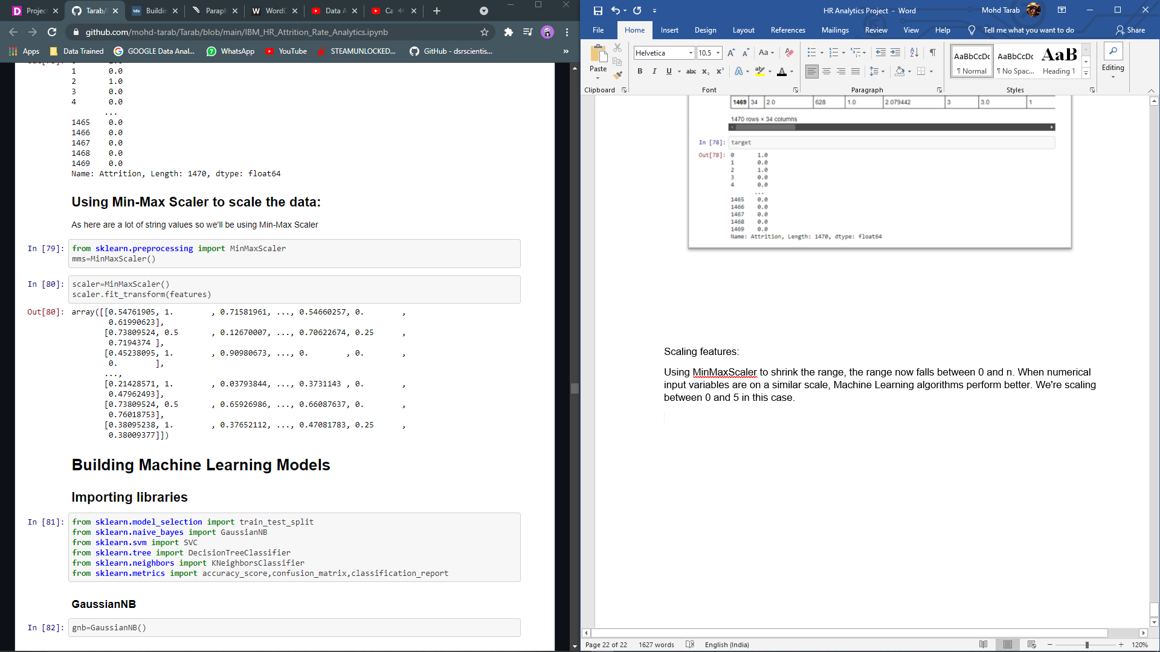

**Building Machine Learning Models**

Finding the best Random State.

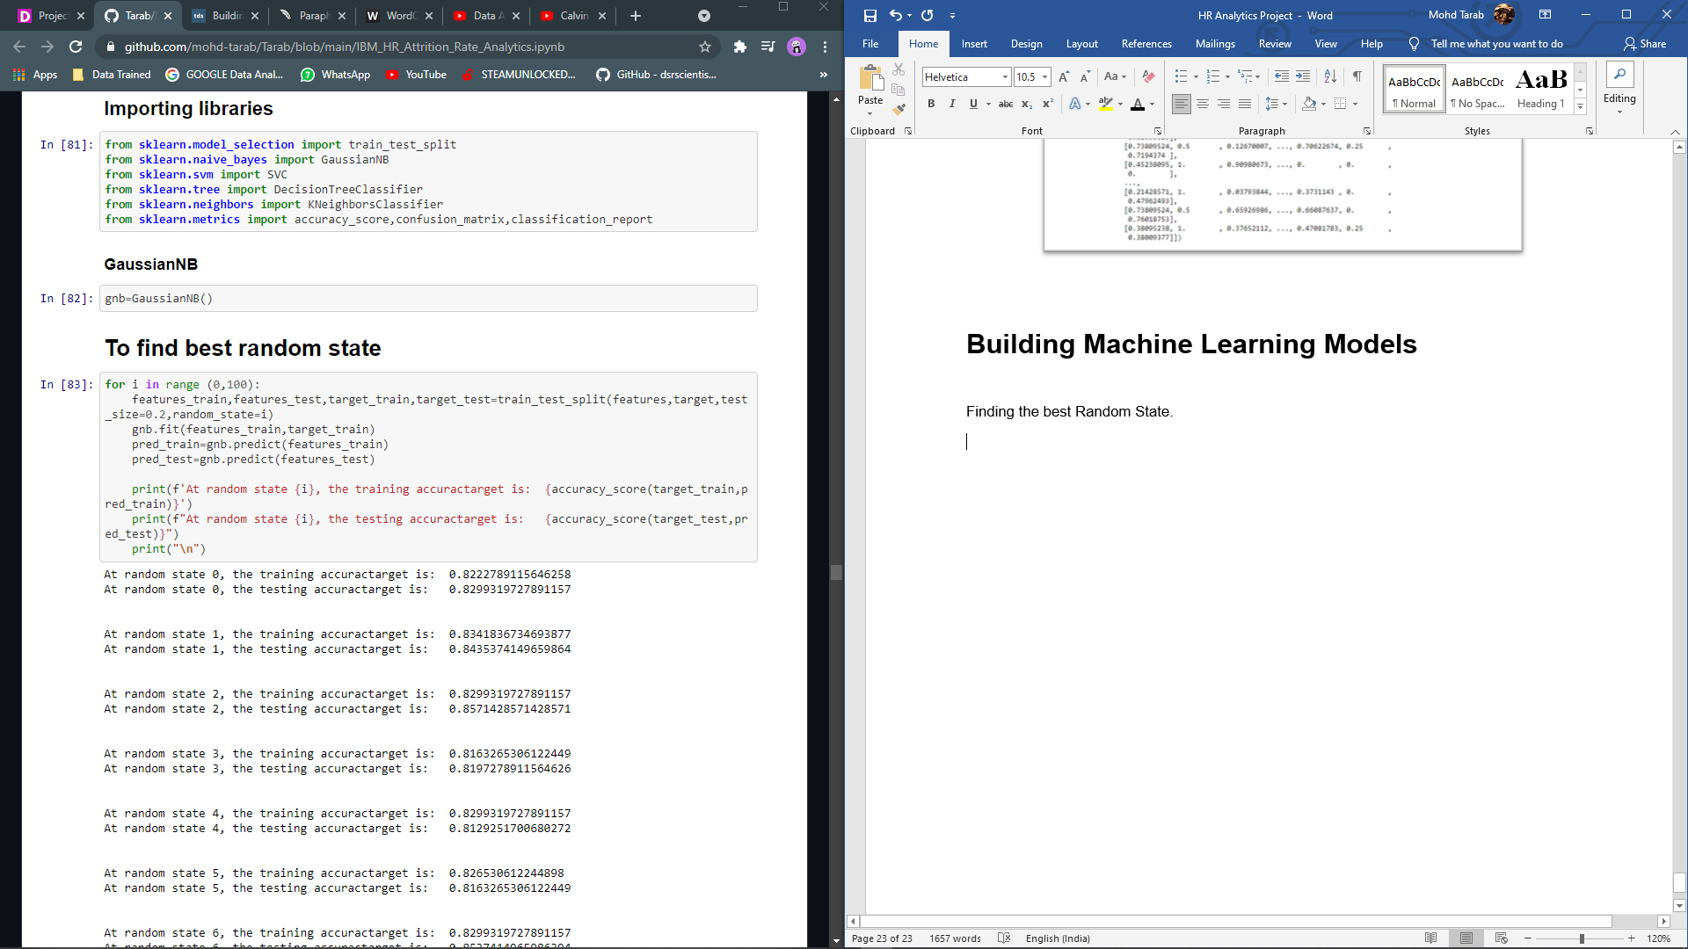

Random State 11 is best, random state for GNB

GaussianNB

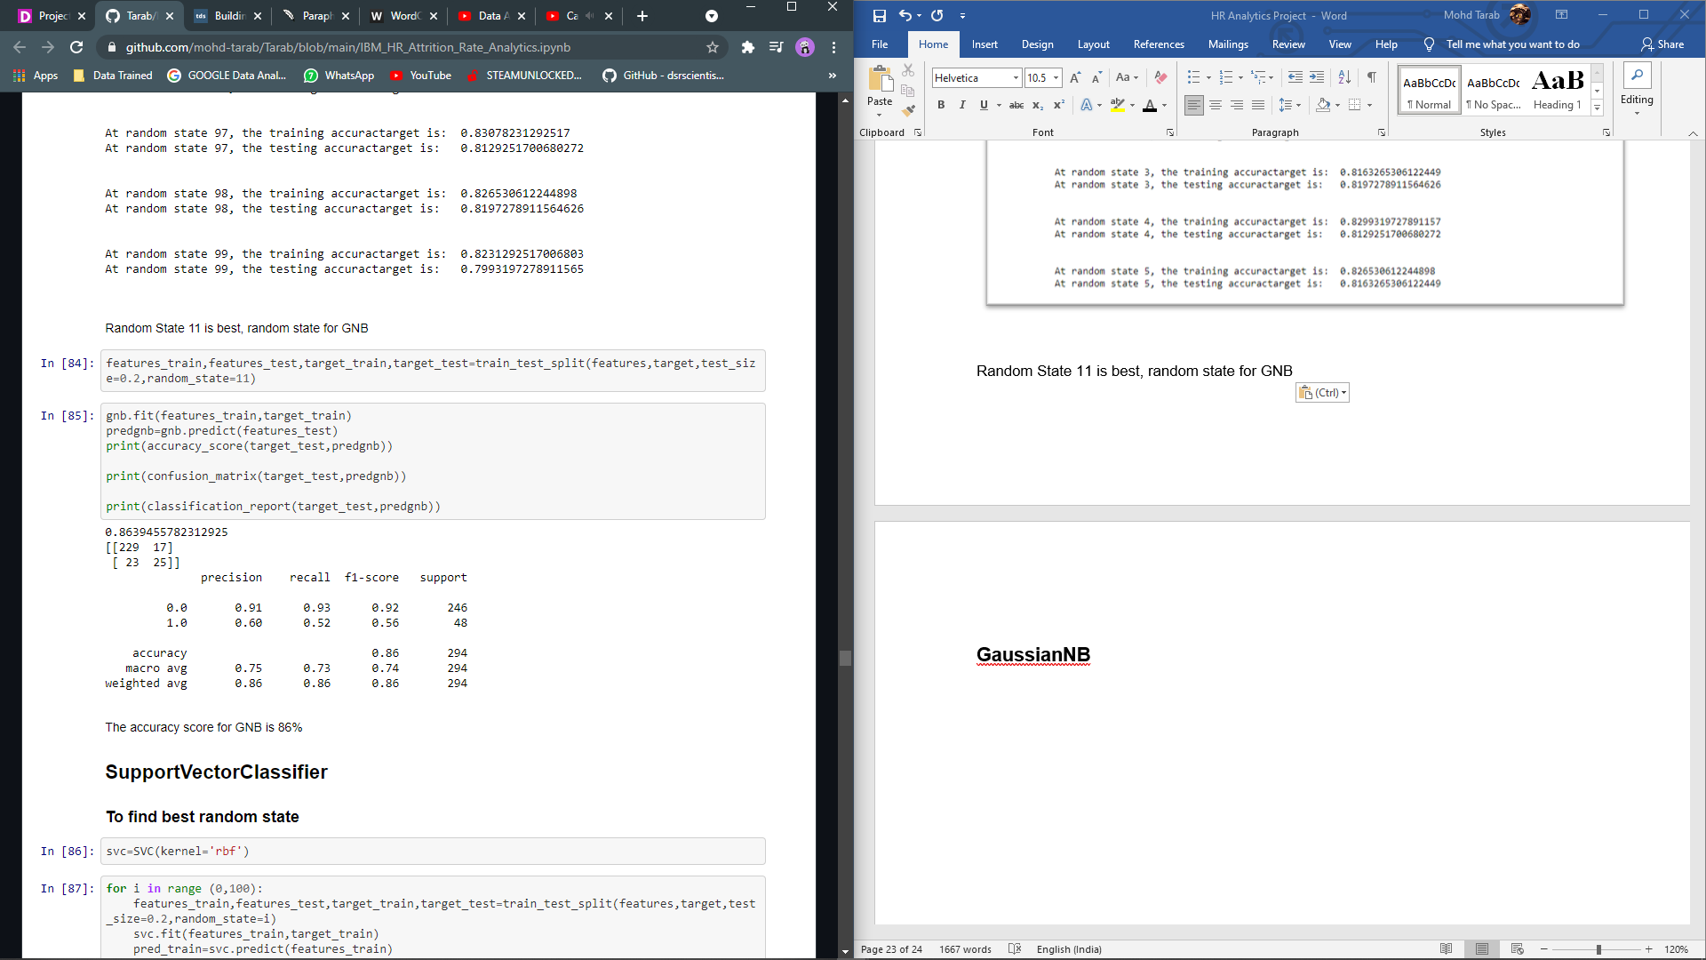

The accuracy score for GNB is 86%

SupportVectorClassifier

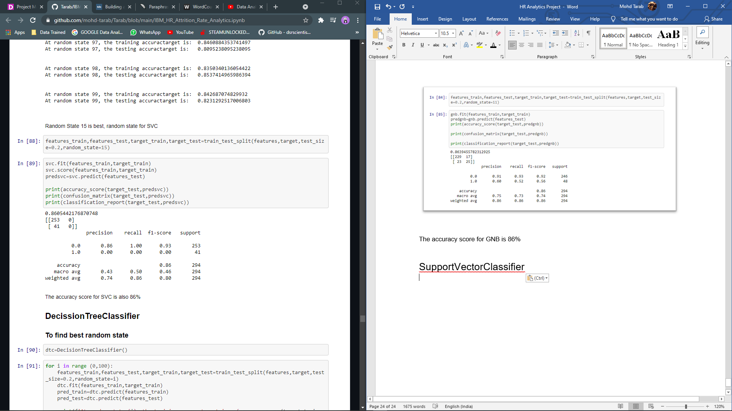

The accuracy score for SVC is also 86%

**DecissionTreeClassifier**

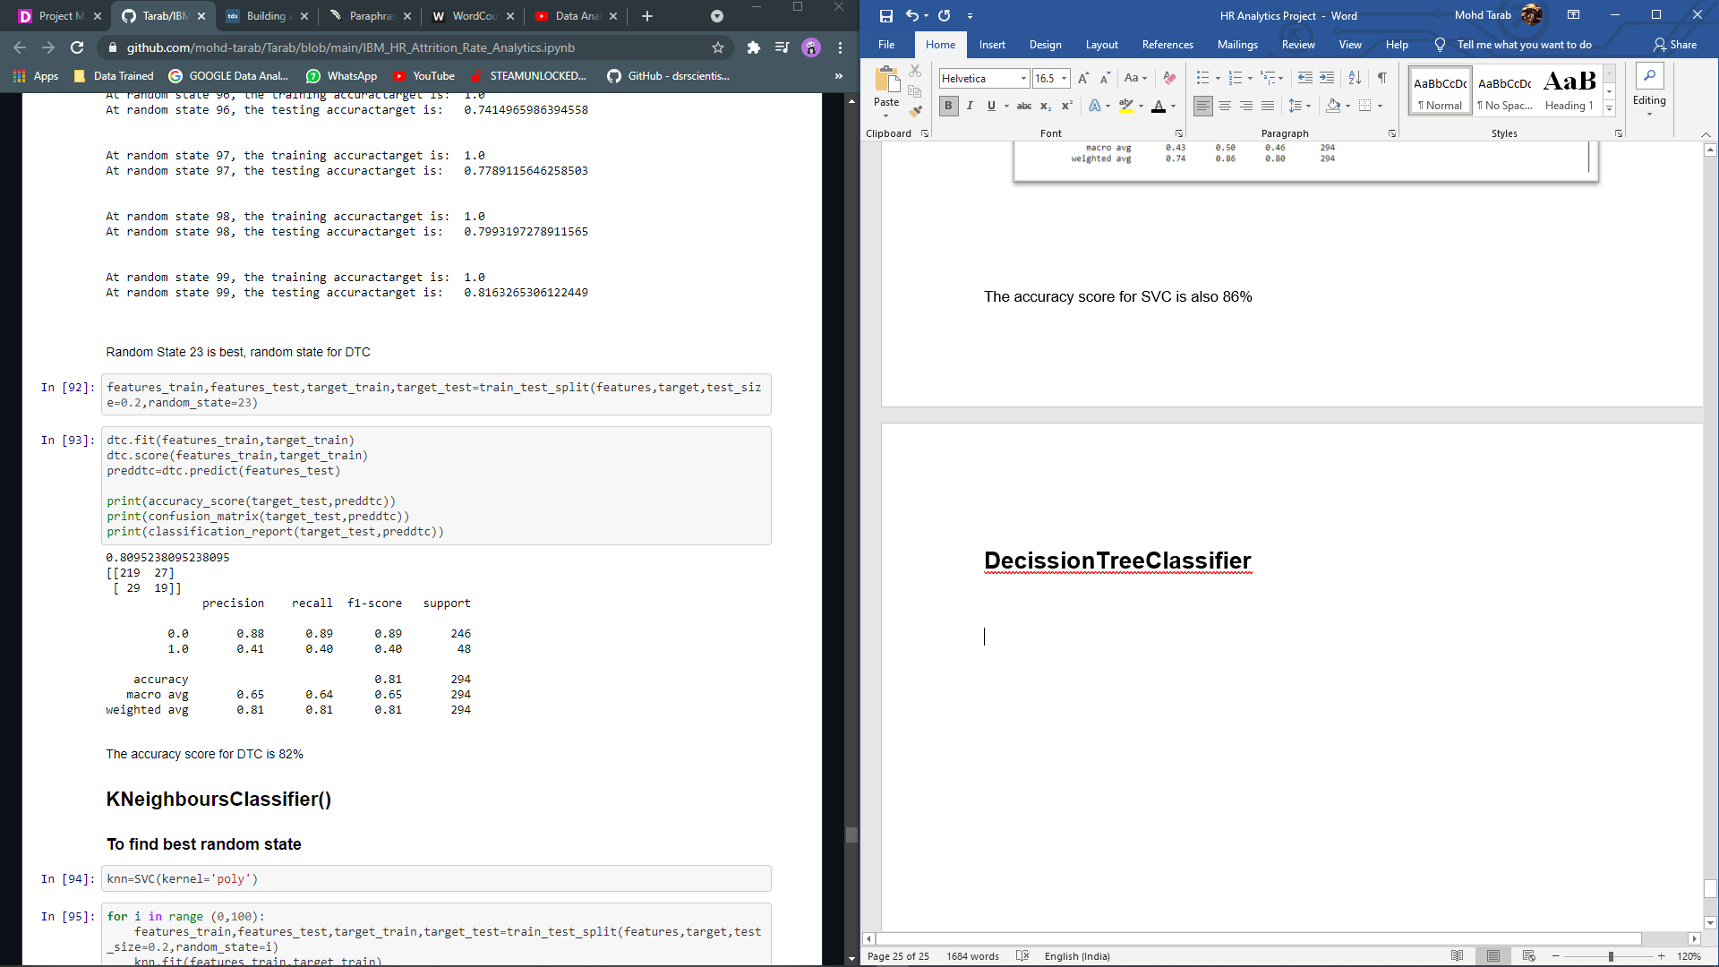

The accuracy score for DTC is 82%

**KNeighboursClassifier()**

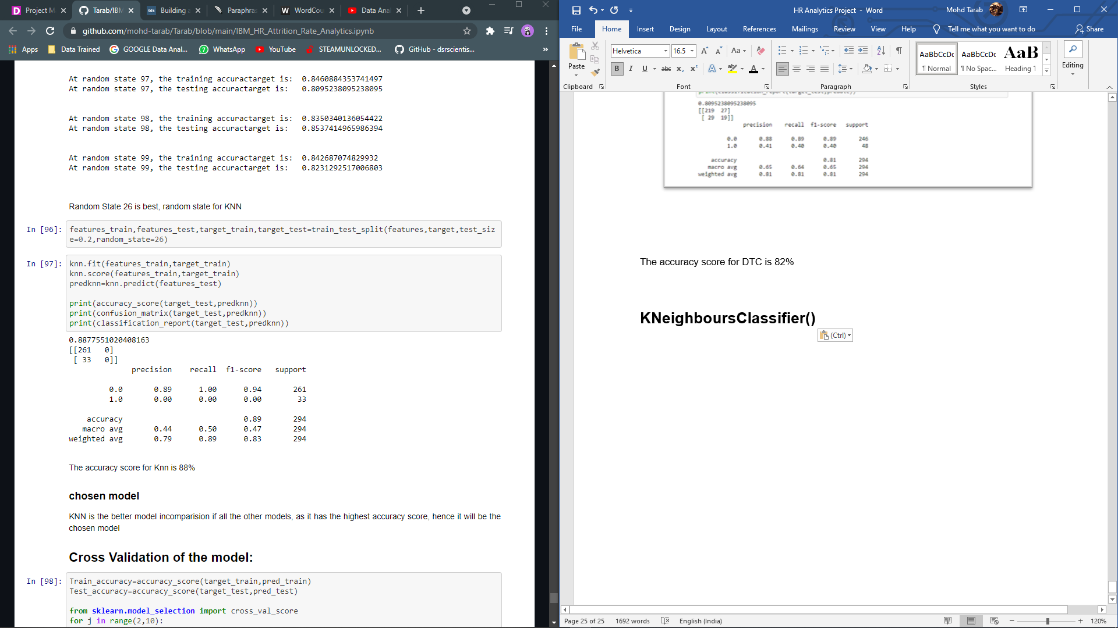

The accuracy score for Knn is 88%

Chosen model

KNN is the better model in comparison if all the other models, as it has the highest accuracy score, hence it will be the chosen model

Cross Validation of the model:

To cross validate our chosen model we will be using Cross validation.

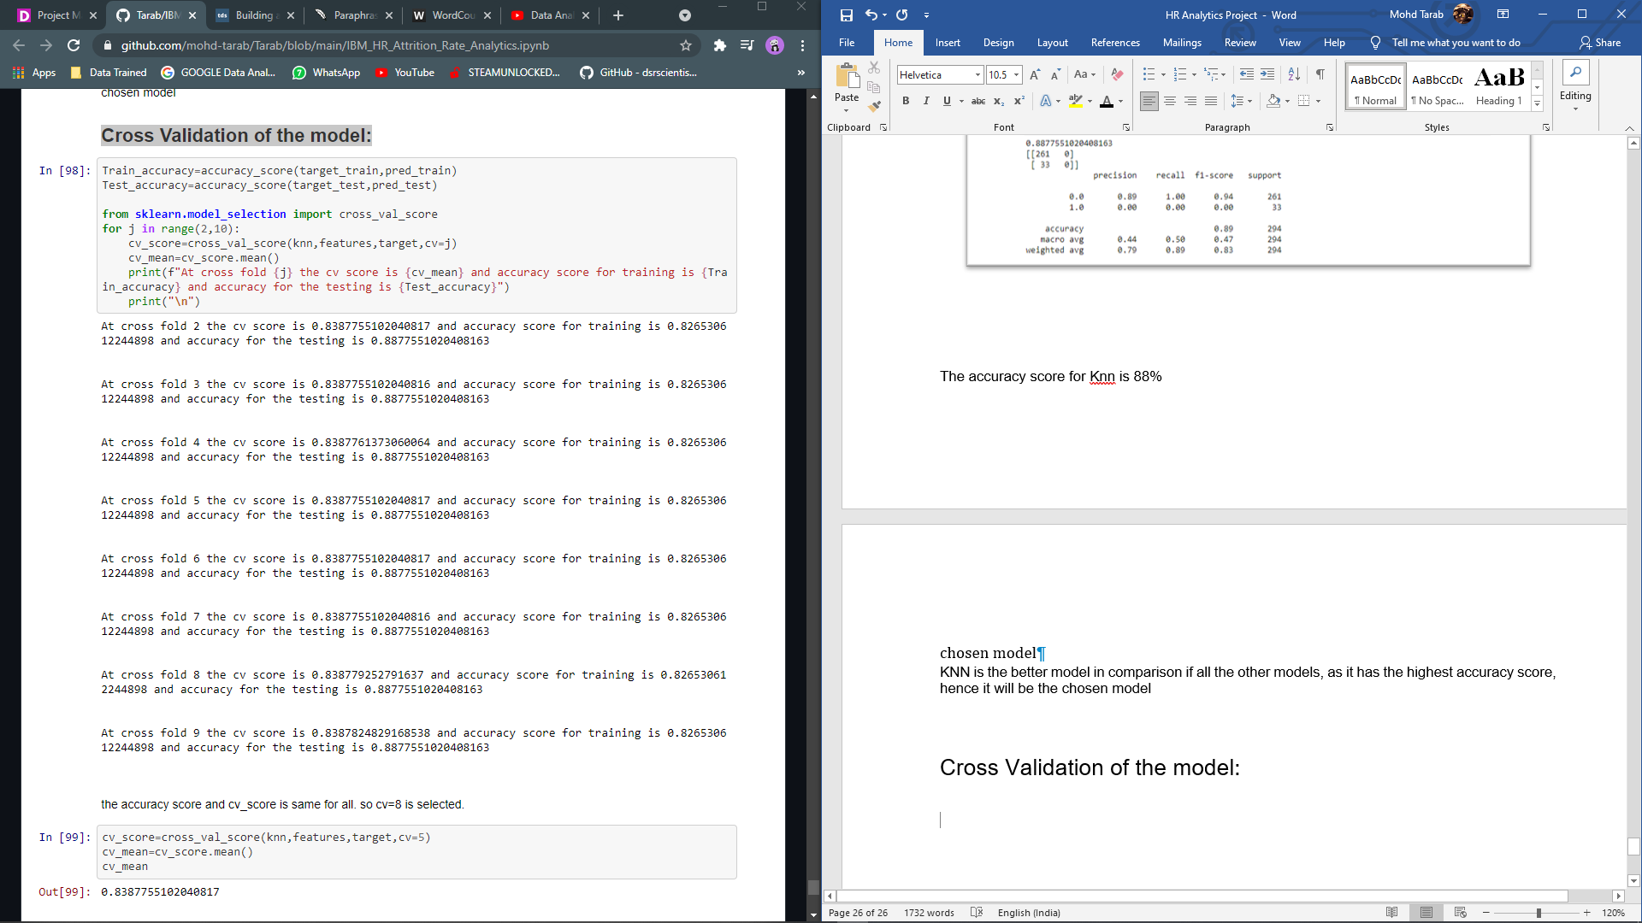

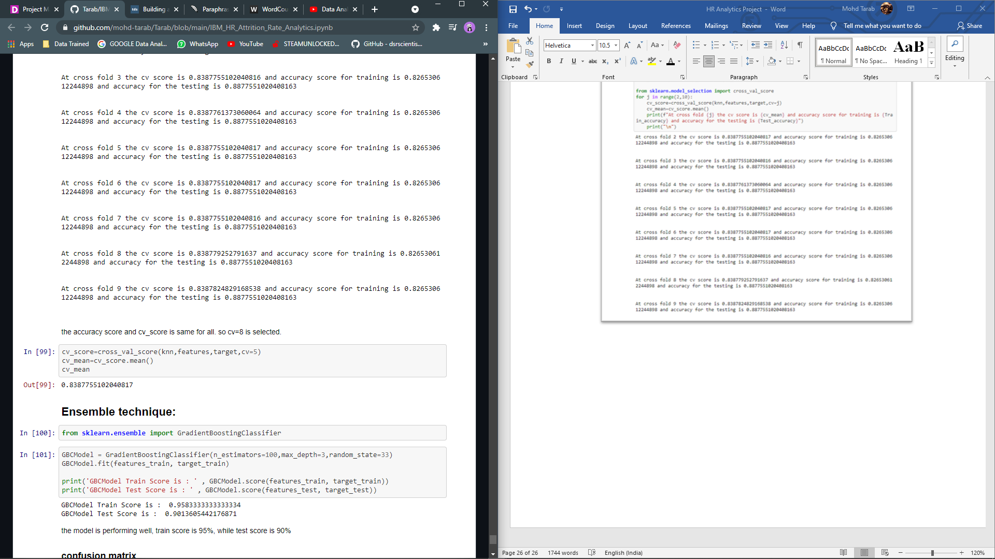

The model is performing good with the cross validation mean 0.83

Ensemble technique

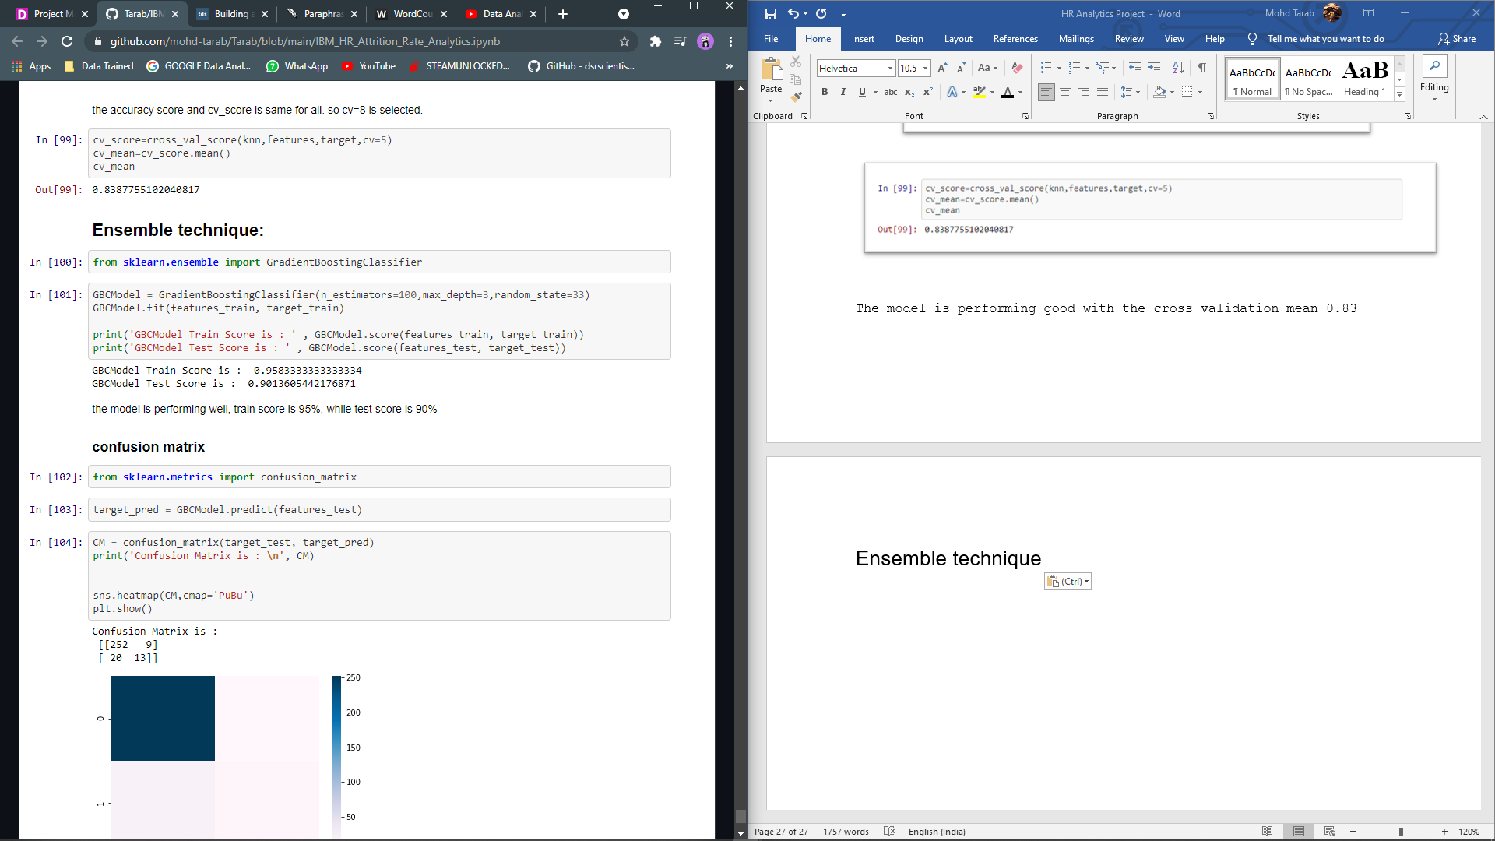

GBC boosted the model score from 80% to 90%, the model is performing well, train score is 95%, while test score is 90%

Confusion matrix

The Confusion matrix gives us a much more accurate picture of the accuracy score and what's going on with our labels; we can see which labels were correctly predicted and which were incorrectly predicted.

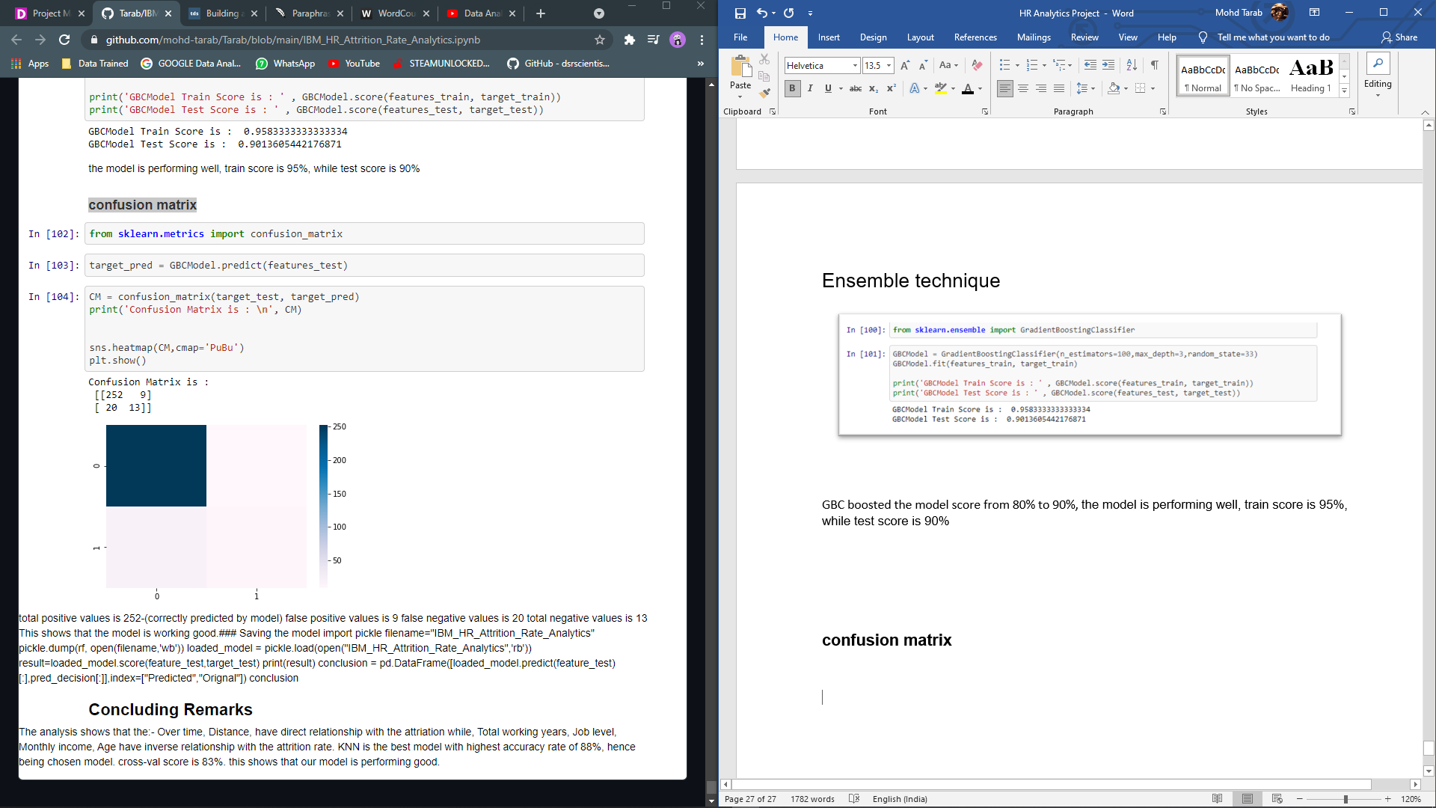

**Conclusion**

Monthly Salary: Employees who earn more money are less likely to leave the business. As a result, attempts should be made to collect information on business benchmarks in the current local market in order to assess if the organisation is paying fair wages.

Overtime: Employees who perform overtime are more likely to resign. As a result, efforts must be made to properly scope tasks ahead of time, with sufficient support and manpower, in order to minimise the use of overtime.

Employees in the 25–35-year-old age group are most likely to resign. As a result, efforts should be made to clearly express the company's long-term vision and how young workers fit into that vision, as well as to include benefits such as direct pathways to promotion.

Employees who live a long distance from their workplace are more likely to resign. As a result, efforts should be made to provide assistance in the form of company transportation or Transportation Allowance for groups of employees leaving the same location. Employees should not be initially screened depending on their home location because this would be considered discrimination as long as they arrive at work on time every day.

TotalWorkingYears: Workers with more experience are less likely to resign. Employees with 5–8 years of experience should be listed as having a higher risk of leaving the business.

YearsAtCompany: Businesses that are loyal are less likely to leave. Employees who have reached their two-year anniversary should be flagged as being at a higher risk of leaving.

YearsWithCurrentManager: A significant number of departing employees quit 6 months after their current managers. Using the Line Manager information for each employee, it is possible to calculate which Managers have had the most employees quit in the last year.